**Name: Muhammad Ali**

**Lab Course Title: Engineering Drawing & CAD Lab**

**Lab Course Code: ME-104L**

**Semester: 2nd Semester (Spring 2020)**

**REG #. 19PWCSE1801**

***Lab Reports***

***Engineering Drawing & CAD Lab***

**Department of Computer system Engineering**



**Submitted to:**

**Engr. Asim Ahmad Riaz**



**University of Engineering & Technology, Peshawar**

**Department of Computer System Engineering**

**Engineering Drawing & CAD Lab**

Dated: 17/08/2020

**Lab Report # 01**

**Introduction to AutoCAD**

* This lab report will contain introduction and definitions drawing and engineering drawing, history and versions of AutoCAD, Benefits and limitation of AutoCAD, CAD softwares, recommended books and software used for this Lab

**Introduction to AutoCAD:-**

**Drawing:-**

The art or technique of representing an object or outlining a figure, plan, or sketch by means of lines.

**Dictionary meaning**:-The definition of a drawing is a picture created with a pen, marker, crayons or other tools, or is the act of making such a picture, or is a contest in which a winner is randomly selected.

**Engineering drawing:-**

An engineering drawing, a type of technical drawing, is used to fully and clearly define requirements for engineered items. Engineering drawing produces engineering drawings. More than merely the drawing of pictures, it is also a language—a graphical language that communicates ideas and information from one mind to another. Most especially, it communicates all needed information from the engineer who designed a part to the workers who will make it.

**AutoCAD:-**

Autocad consist of two word, Auto is logo of the company and CAD means computer-aided design, AutoCAD is a computer-aided design (CAD) program used for 2-D and 3-D design and drafting. AutoCAD is developed and marketed by Autodesk Inc. and was one of the first CAD programs that could be executed on personal computers.

**History:-**

AutoCAD was first released in December 1982 as a desktop app running on [microcomputers](https://en.wikipedia.org/wiki/Microcomputer) with internal [graphics controllers](https://en.wikipedia.org/wiki/Graphics_controller). Before AutoCAD was introduced, most commercial CAD programs ran on [mainframe computers](https://en.wikipedia.org/wiki/Mainframe_computer) or [minicomputers](https://en.wikipedia.org/wiki/Minicomputer), with each CAD operator (user) working at a separate [graphics terminal](https://en.wikipedia.org/wiki/Graphics_terminal). Since 2010, AutoCAD was released as a [mobile-](https://en.wikipedia.org/wiki/Mobile_app) and [web app](https://en.wikipedia.org/wiki/Web_app) as well, marketed as AutoCAD 360.

**Version:-**

We will use 2007 version at the beginning and familiar with 2007 version for a while. At the end we also study and use autocad 2020.

**Benefit of autocad:-**

**1.** **AutoCad software is helpful, It has a large set of parts and features that you can choose for your designs, It offers powerful and quick dimensions, You can use the simplified tools, you can generate the dimensions to control and expand only the important variables for manufacturing easily.**

**2 .AutoCad software is incorporation for International Drafting Standards, Compliance with the industry standards improves the internal communication and the results in reliable production outputs, It presents** **easy data swapping, It comes with in-built industry, standard STEP and IGES formats for the exchanging data between different CAD systems.**

**3 .AutoCad software comes with specific drafting tools for generating standards Industry based geometric dimensions, surface texture symbols, the mechanical symbols and the weld symbols, and AutoCAD firm can increase their productivity manifold.**

**4. AutoCad software automatically redraws the geometry to illustrate the dashes and the hidden lines of parts which are blocked by the other parts in the mechanical design, It enables you to produce very accurate designs, and drawings can be created in 2D or 3D and rotated.**

**5. AutoCad software reduced the design timescales, Reuse of the designs, The drawing errors can be corrected easily, The drawings can be sent/received via email in seconds, and AutoCad software offers rapid prototyping.**

**Limitation of autocad:-**

**Autocad software is not so much suited for 3D as it has fewer options, It can not be used in the complex designs, If you are into the heavy assembly work don’t rely on this software, It cannot be used in Complex Programming, A large amount of memory and speed is required, Training and equipment are very costly.**

**AutoCad software has expansive start-up costs (the hardware, the software, and training), It can be very expensive, so, the initial costs are high, There are free software packages though, The people need to be trained on how to use the software that also adds to the costs, and it requires a PC.**

**AutoCad software needs the time & the cost of implementing the system, It needs time & cost of training the people to use it, so, It is very expensive in training, It needs the time & the cost of migrating legacy drawings into AutoCAD format.**

**CAD Softwars:-**

CAD, or computer-aided design and drafting (CADD), is technology for design and technical documentation, which replaces manual drafting with an automated process.

**Examples:-**

 1. TinkerCAD

2. FreeCAD

3. BlocksCAD

4. Creo

5. Fusion 360°

6. Solidworks

7. AutoCAD

**Recommended books:-**

1. “Engineering Drawing and Graphics” by K Venugopal

2. “Engineering Drawing” by N D Bhatt and V M Panchal

3. “Engineering Graphics” by B Bhattacharyya

4.“Machine Drawing” by N Sidheswar and P Kannaiah

5. “Technical Drawing with Engineering Graphics” by Frederick E Giesecke and Ivan L Hill

6. “Engineering Drawing” by N S Parthasarathy and Vela Murali

7.“Engineering Graphics” by T Jeyapoovan and S Gowri

8. “A Textbook of Engineering Drawing” by R K Dhawan



**University of Engineering & Technology, Peshawar**

**Department of Computer System Engineering**

**Engineering Drawing & CAD Lab**

Dated: 17/08/2020

**Lab Report # 02**

**Introduction to AutoCAD Graphical User Interface (GUI) and General commands, setting up drawing sheet, Units & toolbars**

* This lab report will contain; what is GUI and mark different parts of AutoCAD graphical screen.

1. Title Bar 2. Menu Bar 3.The Standard toolbar

4. Command prompt area

* Write step-wise procedure for Launching AutoCAD, setting workspace, Putting the User Interface to work, Setting toolbars for quick use etc.
* Explain each component and toolbar along with figures

**Graphical user interface:-**

When you start AutoCAD After installing you will be presented with Welcome Screen(Work, Learn and Extend) . Press close on it. Now AutoCAD window will be open. For better understanding of AutoCAD User Interface.

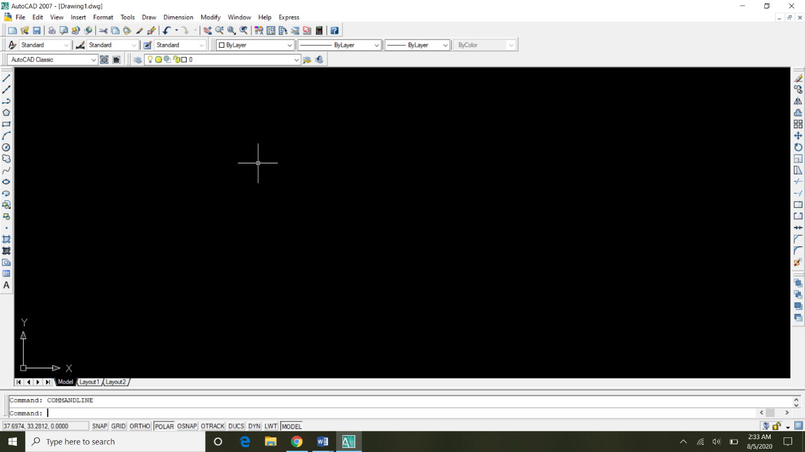

**General commands:-**

This is the list of some of the most basic AutoCAD commands which every AutoCAD user should know. These are some of the Draw and Modify commands which make the very basics of AutoCAD.

## ****L****

It can be used for making simple lines in the drawing.

## ****C****

It is the command used for making a circle in AutoCAD.

## ****PL****

This command can be used to make a Polyline in your drawing.

## ****REC****

This command will make a rectangle in AutoCAD.

## ****POL****

This command can be used to make a polygon with minimum of 3 sides and a maximum of 1024 sides.

## ****ARC****

As the name suggests, this command can be used to make an arc in AutoCAD.

## ****ELLIPSE****

As the name suggests, this command can be used to make an ellipse with the major and minor axis.

## ****Ctrl + N****

You can use this shortcut to open a new drawing a tab in AutoCAD.

## ****Ctrl + S****

You can use this keyboard shortcut to save a drawing file.

## ****Ctrl + Shift + S****

You can use this keyboard shortcut to save the drawing as a new file, in short, this is the hotkey for “save as” command.

## ****Ctrl + 0****

Clears screen to show only the drawing area and hides palettes and tabs. Press it again to reset default AutoCAD interface.

## ****Ctrl + 1****

Select and object and press Ctrl + 1 to open the properties palette which lists properties of the object. You can use this palette to modify most of the properties of the object too. You can also use PR command to open the property palette.

## ****Ctrl + 2****

You can use it to open design center palette which contains many AutoCAD blocks that can be used directly in your drawing.

## ****Ctrl + 9****

You can use this keyboard shortcut to toggle the visibility of the command line. If for some reason your command line is hidden from the drawing area, then use this keyboard shortcut to bring it back.

**Title bar:-**

The title bar is a horizontal bar located at the top of a [window](https://www.computerhope.com/jargon/w/window.htm) in a [GUI](https://www.computerhope.com/jargon/g/gui.htm). It displays the title of the [software](https://www.computerhope.com/jargon/s/software.htm), name of the current [document](https://www.computerhope.com/jargon/d/document.htm), or other text identifying the contents of that window. For example, in the picture below, the title bar displays the program name "TextPad" and the document name "Document1" that is currently being edited.

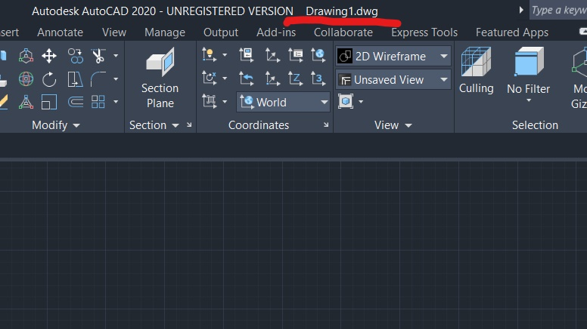

**Menu bar:-**

Menu bar can be shown if we goes to customize quick access toolbar and scroll down to click on “Show Menu Bar" the horizontal list of tools will be display below the title bar. Menu consist of File, views, Edit, format, draw, modify, dimension etc.

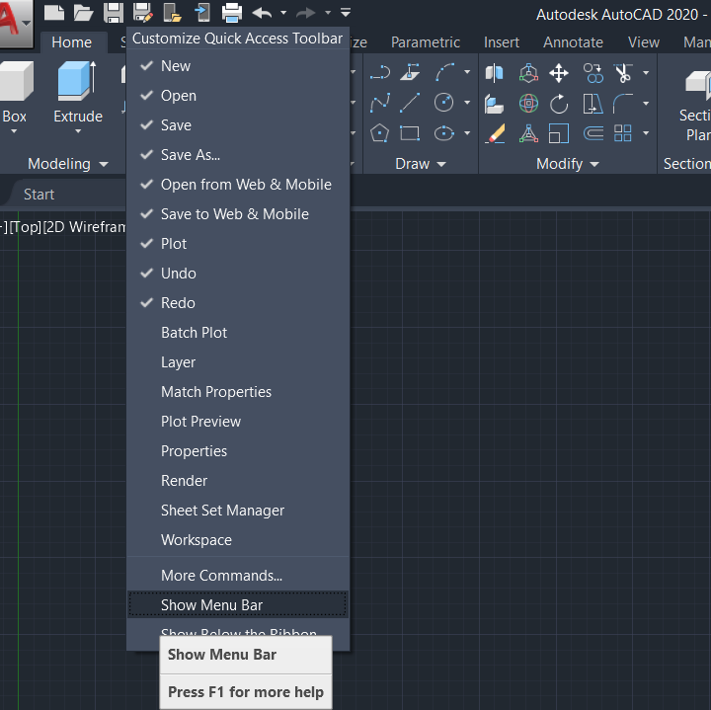

**Command prompt area:-**

Command prompt area is used for command, enable by shortcut key. We type shortcut in command prompt area and press enter (like F8 for ortho) ortho command will enable.

To open the Command line, type Command Line anywhere in your CAD interface. Then press Enter. The Command line will reappear.

You can also open the Command line by holding down the CTRL + 9 keys.

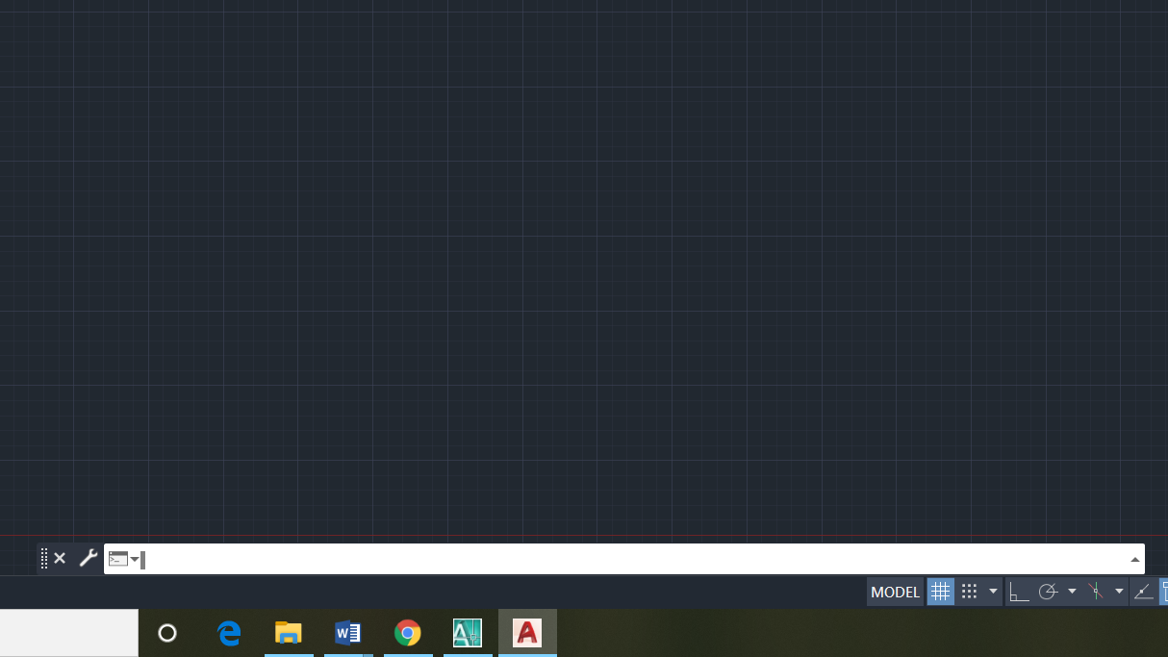

**Launching autocad:-**

By the Start button on the toolbar Windows or through direct clicks on an icon or a file that was made in AutoCAD. Here I will not hold back because I believe that you have a base knowledge to work in Windows operating system and know how to run a software application.  After starting the AutoCAD window will appear like this in the picture below where you select the type of work in AutoCAD 2007.

[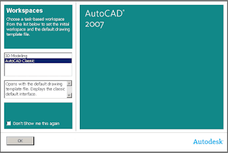](https://3.bp.blogspot.com/-cl8qs3J_XF8/WlpOZ6nemPI/AAAAAAAAAfM/jqdKVQjYmFceRT12kibv4BKSaQL-IRFpgCLcBGAs/s1600/startni-prozor.png)

After running AutoCAD that you may see the following window as shown below (and not, depending on whether this option is turned on) if not, at the end of this page, see how to include and exclude options.

[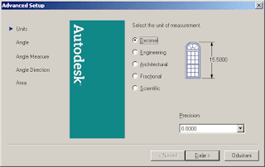](https://4.bp.blogspot.com/-LBvjl-z8ydQ/WlpOw2BXkiI/AAAAAAAAAfQ/2J56-ZkDcV8Jh-DCBhMjFMfhyYfbiMZYACLcBGAs/s1600/advance-startup1.png)

Set your only angle measurements as well as its accuracy (version number in decimal form)

[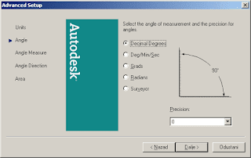](https://2.bp.blogspot.com/-mFmo5n7OPcY/WlpPGTglPYI/AAAAAAAAAfY/qN0bxTeaSv4964XPRogW8aJTblR4hYzZACLcBGAs/s1600/advance-startup2.png)

Setting the baseline for the direction of drawing Angle Measure - EAST

[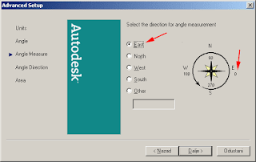](https://2.bp.blogspot.com/-2GkhbFL8yPY/WlpPhDSUuJI/AAAAAAAAAfc/ebl1ifnJXLcZclU_iWHMCX7jBE0RQEdnQCLcBGAs/s1600/advance-startup3.png)

Setting the direction of drawing a "Counter Clockwise" in the opposite direction from clockwise (in geodesy is set to Clockwise)

[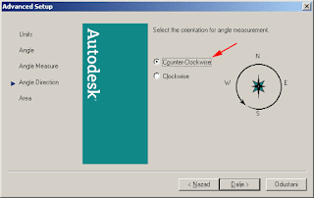](https://3.bp.blogspot.com/-hjE-b6WKHEw/WlpP2oD6xlI/AAAAAAAAAfk/g5GRquoiCXY-5PH0cyrmWznAi2zkDYVRwCLcBGAs/s1600/advance-startup4.png)

Here in the option area, you can set the size of the drawing area (not a must, but then you can use the scale to print on paper (PLOT)

[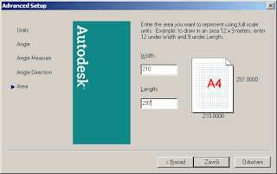](https://1.bp.blogspot.com/-O1N8WNiVWDI/WlpQXQQuW3I/AAAAAAAAAfs/T-Ob-2ZIGW8FPjnEE-Xm-WGIRluq38bpgCLcBGAs/s1600/advance-startup5.png)

Speaking of determining the size of the area for drawing, as long as you need STARTUP dialog window, and furthermore, you can set the size of the area, drawing the border.

Setting workspace:-

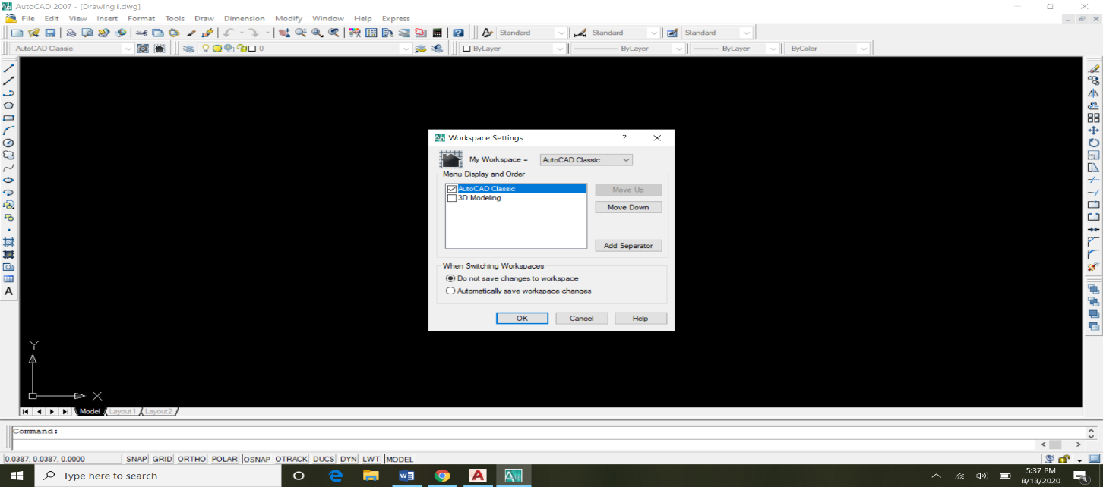

* On the status bar, click Workspace Switching, and select the workspace you want to set current. (  Find)
* Set a workspace current from the Customize User Interface (CUI) Editor:
  1. Click Manage tab  Customization panel  User Interface.  Find
  2. In the Customize tab, Customizations In *<file name>* pane, click the plus sign (+) next to the Workspaces node to expand it.
  3. Right-click the workspace you want to set current. Click Set Current.

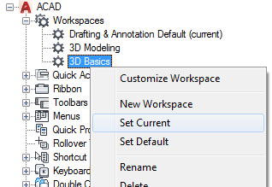

* 1. Click Apply.

Save Changes to a Workspace from the Application Window

1. On the status bar, click Workspace Switching, select Save Current As.
2. In the Save Workspace dialog box, Name box, enter a name to create a new workspace or select an existing workspace from the drop-down list to overwrite it.

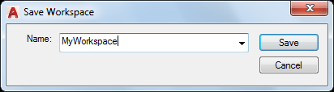

1. Click Save to create or modify the workspace.

**User interface to work:-**

I will give to assume that we have the software already installed on your computer and ready for use.

Below we show some pictures of the interface of different versions of AutoCAD, from the oldest to the most recent, which the various control buttons are been slightly updated in both graphically and in the layout.

Do not worry for now; keep in mind that in general the symbols represented are the same.

AutoCAD is produced in LT (light) version and in the normal version, (Full).  
The light version does not have the ability to create 3D designs (three-dimensional), but can open and view it, and with the most comprehensive and expensive full version, you can create it, through dedicated instruments and additional functions.  
This course will describe the basic functions of the 2D software.

AutoCAD 2007/2008

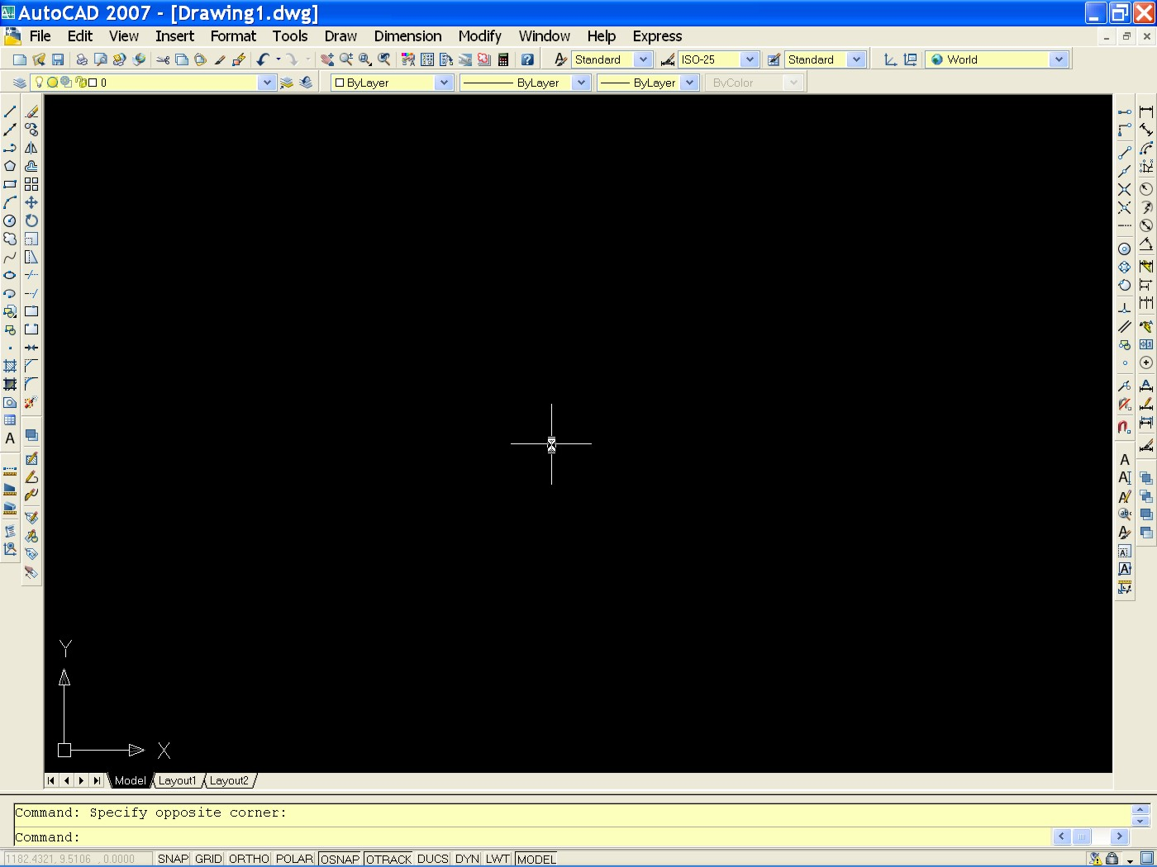

Over here an “old” version of AutoCAD that as you can see, similarly to almost all programs for Windows, it appeared with a line of pop-up menu at the top, with the commands “File, Edit, View, Insert etc...”.

We have also various “toolbars”, that is all those buttons corresponding to the various commands that we will see later, which are divided into groups that can be customized by making them visible or not visible and moved to the desired position.  
In subsequent years, the interface has changed.

**Display the Customize User Interface (CUI) Editor:-**

* Click Manage tab  Customization panel  User Interface.  Find

Create a Quick Access Toolbar

1. In the Customize tab, Customizations In <file name> pane, right-click the Quick Access Toolbars node. Click New Quick Access Toolbar.

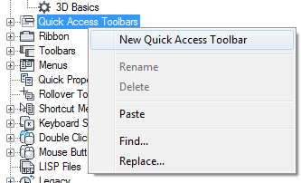

A new Quick Access toolbar (named Quick Access Toolbar1) is placed at the bottom of the Quick Access Toolbars node.

1. Right-click Quick Access Toolbar1. Click Rename and enter a new name.

Note: You can click, wait, and click again over the Quick Access toolbar’s name again to edit its name in-place in the Customizations In < file name> pane.

1. Click Apply.

**Delete a Quick Access Toolbar:-**

1. In the Customize tab, Customizations In <file name> pane, click the plus sign (+) next to the Quick Access Toolbars node to expand it.
2. Right-click the Quick Access toolbar you want to delete and click Delete.

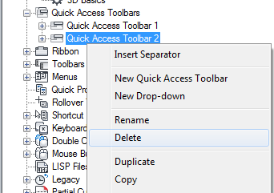

1. Click Apply.

Add a Command or Control (CUI Editor)

1. In the Customize tab, Customizations In <file name> pane, click the plus sign (+) next to the Quick Access Toolbars node to expand it.
2. Click the plus sign (+) next to the Quick Access toolbar that you want to modify.
3. Under the Command List pane, drag the command or control you want to add to the Quick Access Toolbar under the Customizations In <file name> pane.

A visual indicator bar is displayed to indicate the location where the command or control will be added when you release the pointing device button.

1. Once the visual indicator bar is in the location you want to insert the command or control, release the pointing device button.
2. Click Apply.

**Add a Drop-down:-**

1. In the Customize tab, Customizations In <file name> pane, click the plus sign (+) next to the Quick Access Toolbars node to expand it.
2. Click the plus sign (+) next to the Quick Access toolbar that you want to modify.
3. Right-click the Quick Access toolbar which you want to add a drop-down to. Click New Drop-down.

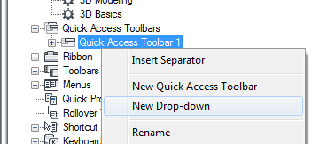

A new drop-down (named New Drop-down) is added to the bottom of the Quick Access toolbar.

1. Right-click the new drop-down. Click Rename and enter a new name.

Note: You can click, wait, and click again over a drop-down name to edit its name in-place in the Customizations In <file name> pane.

1. Drag the drop-down under the Quick Access toolbar to the position where you want it placed. Release the pointing device button to reposition the drop-down.

Use the visual indicator bar that is displayed to help specify the location for the drop-down.

1. Under the Command List pane, drag the command or control you want to add to the drop-down menu under the Customizations In <file name> pane.

**University of Engineering & Technology, Peshawar**

**Department of Computer System Engineering**

**Engineering Drawing & CAD Lab**

Dated: 17/08/2020

**Lab Report # 03**

**Setting Up Drawing unit, Drawing sheet, Dimension style and Text style**

Write down a stepwise procedure for Setting Up Drawing unit and Drawing sheet, Dimension style and Text style along with figure and images if required

**Procedure Setting up Drawing unit:-**

It is important to know the units of your drawing while working on AutoCAD. AutoCAD units are most time what you should care about before starting any project. The default units is set to inches.

We have a good article that will help you handle your [settings in AutoCAD](https://tutorial45.com/autocad-tutorial-05-best-settings-in-autocad/) when you have just started.

## AutoCAD units

It is possible to draw in AutoCAD using the following units:

* Inches
* Feet
* US Survey Feet
* Miles
* Millimeters
* Centimeters
* Meters
* Kilometers
* Microinches
* Mils
* Yards
* Angstroms
* Nanometers
* Microns
* Decimeters
* Dekameters
* Hectometers
* Gigameters
* Astronomical
* Light years
* Parsecs
* Unitless

## How to change units in AutoCAD:-

To change the units in AutoCAD:

### **Step 1**

Type **Units** and Hit **ENTER** on your keyboard, the following window should pop up.

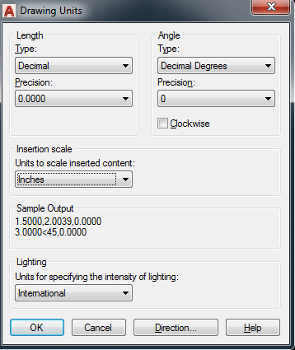

### **Step 2**

Click on the drop down menu under **Insertion scale**, select the appropriate unit and click on **OK**.

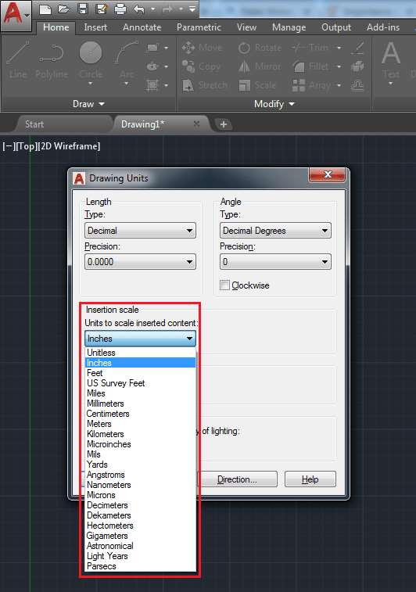

**Drawing sheet:-**

1. Click Application menu New  Sheet Set.  Find
2. Follow the steps in the Create Sheet Set wizard. Choose *one* of the following options:
   * An Example Sheet Set. When you create a sheet set using this option, the example sheet set provides the organizational structure and default settings for the new sheet set. Specify that folders are created corresponding to the subset storage paths of the sheet set. After you create an empty sheet set with this option, you can Import layouts or create sheets individually.
   * Existing Drawings. When you create a sheet set using this option, you specify one or more folders that contain drawing files, and you can specify that the subset organization for the sheet set duplicates the folder structure of the drawing files. The layouts from these drawings can be imported into the sheet set automatically.

Important: Make sure that none of the layout tabs in the drawings that you want to include use names that include a # character.

1. Enter the name, description and location of the new sheet set.
2. Click Finish to display the newly created sheet set in the Sheet Set Manager.

**Dimension style:-**

1. Click Home tabAnnotation panelDimension Style. 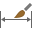 Find
2. In the Dimension Style Manager, click New.
3. In the Create New Dimension Style dialog box, enter a name for the new dimension style, and click Continue.
4. In the New Dimension Style dialog box, click each tab, and make any changes for the new dimension style.
5. Click OK and then Close to exit the Dimension Style Manager.

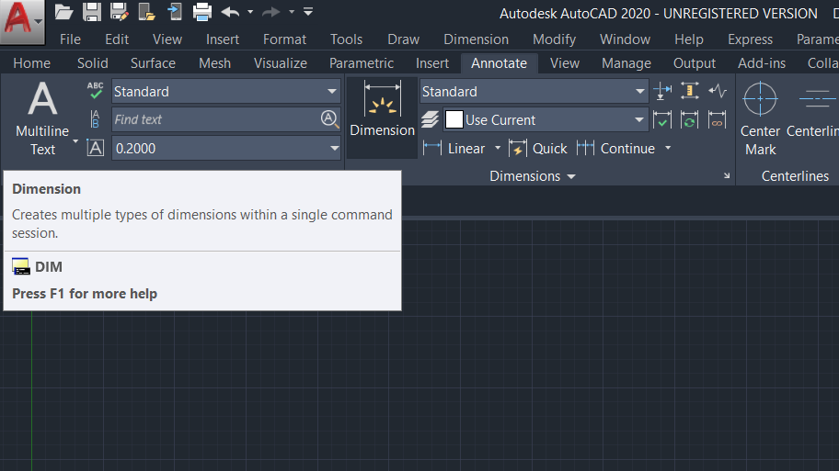

**Text style:-**

1. Click Home tabAnnotation panelText Style.  Find
2. In the Text Style dialog box, do one of the following:
   * To create a style, click New and enter the style name.

Note: Text style names can be up to 255 characters long. They can contain letters, numbers, and the special characters dollar sign ($), underscore (_), and hyphen (-).

* + To modify an existing style, select the style name from the list of styles.

1. Font. Under Font Name, select the font you want to use. TrueType fonts display a TrueType icon in front of their names. 
   * To assign an Asian-language font, select the name of an SHX font file, check Use Big Font, and select an Asian-language big font.
2. Size. In the Height box, enter the text height in drawing units.
3. Oblique angle. Under Effects, enter an angle between -85 and 85 in the Oblique Angle box.

A positive value slants text to the right. A negative value slants text to the left.

1. Character spacing. Under Effects, enter a value in the Width Factor box.

Entering a value less than 1.0 condenses the text. Entering a value greater than 1.0 expands it.

1. Annotative. Check this option so that any text using this style displays uniformly at the same size or scale regardless of the scale of the view.
2. Specify other settings as needed.
3. To update text of the current style in the drawing, click Apply.
4. Click Close.



**University of Engineering & Technology, Peshawar**

**Department of Computer System Engineering**

**Engineering Drawing & CAD Lab**

Dated: 17/08/2020

**Lab Report # 04**

**Opening, Saving, and Printing AutoCAD sketches & Introduction to basic commands (Zoom and Pan)**

Write down a stepwise procedure for Opening, Saving, and Printing AutoCAD sketches along with figure and images if required

Discuss each option in zoom command and Pan in this report alongwith figures and images

**Opening:-**

1. Click Application Menu open select sketch
2. After clicking on open a popup window will be disappear consist of different sketches .
3. Select the file you want to open or tap on dialog box.
4. Click Ok.

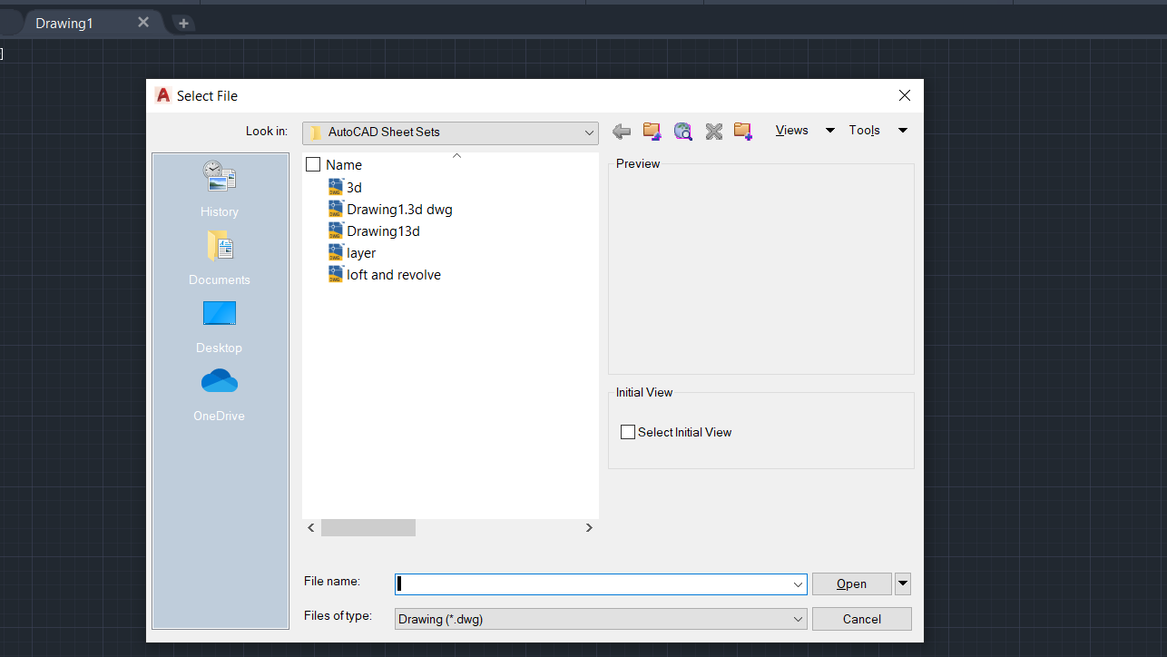

**Steps for saving:-**

1. Click Application Menu Save AsOther Formats.   Find
2. In the Save Drawing As dialog box, in the File Name box, enter a new drawing name.
3. Under Files of type, select the AutoCAD or AutoCAD LT file format you want.
4. Click OK.

**Printing autocad sketches :-**

1.Click on output toolbar in autocad2020 plotset setting.

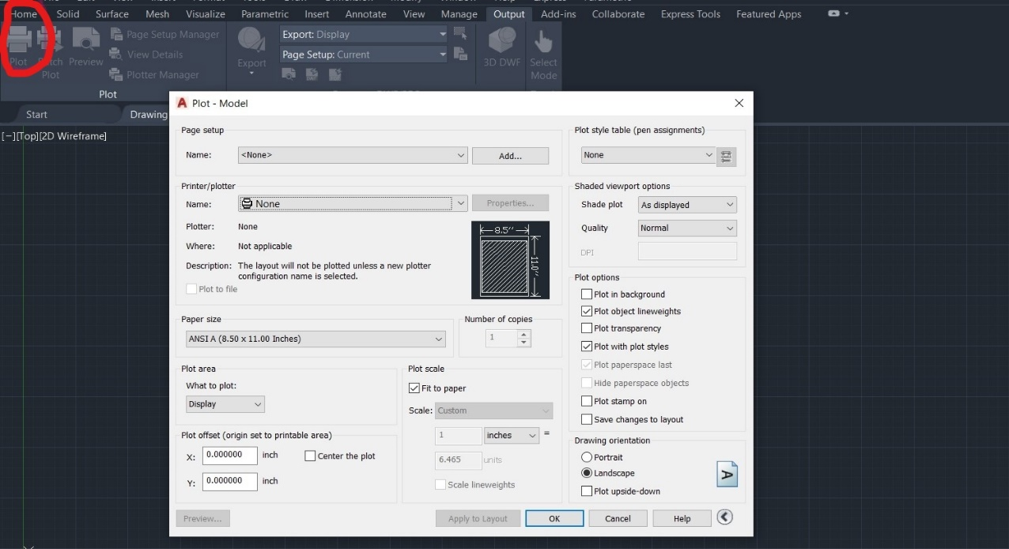

2. To plot a drawing to PDF press CTRL+P on keyboard or type PLOT on the command line and press enter, this will open plot window in AutoCAD. Select DWG to PDF.pc3 plotter from the list of plotters.

[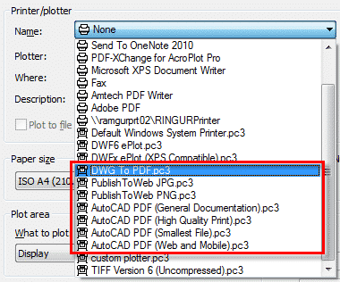](http://localhost/sourcecad/wp-content/uploads/2015/12/printer-menu-autocad.png)

## ****3.PDF Options:****

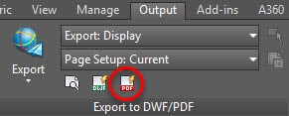

You can manage the quality of PDF output from Vector Quality and Raster Quality drop down menus. You can change the resolution value to suit your needs, a higher resolution will allow quality printing but it will also consume more ink. So always try to print your drawings with optimal resolution value.

If you are creating the PDF for display on monitors then a higher resolution value can be selected.

4.The Merge Control drop down menu will control the overlapping lines of the drawings. Lines Overwrite option will create the lines with the colour of line on the top at the intersection point, whereas Lines Merge option will make lines of merged colour at the intersection.

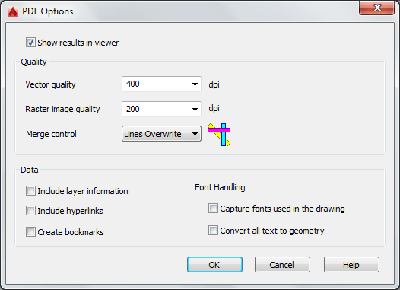

**Basic command:-**

**Zoom :-**

Increases or decreases the magnification of the view in the current viewport.

 Find

You can change the magnification of a view by zooming in and out, which is similar to zooming in and out with a camera. Using ZOOM does not change the absolute size of objects in the drawing. It changes only the magnification of the view.

In a perspective view, ZOOM displays the 3DZOOM prompts.

The following prompts are displayed.

**Corner of window**

Specify one corner of the area to be zoomed into.

* **Opposite corner.**Specify the opposite corner of the zoom area.

**All**

Zooms to display all visible objects and visual aids.

Adjusts the magnification of the drawing area to accommodate the extents of all visible objects in the drawing, or visual aids such as the grid limits (the LIMITS command), whichever is larger.

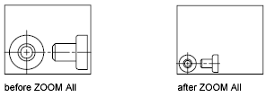

In the illustration on the right, the grid limits are set to a larger area than the extents of the drawing.

Because it always regenerates the drawing, you cannot use ZOOM All transparently.

**Center**

Zooms to display a view defined by a center point and a magnification value or a height. A smaller value for the height increases the magnification. A larger value decreases the magnification. Not available in perspective projection.

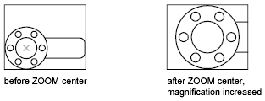

**Dynamic**

Pans and zooms using a rectangular view box. The view box represents your view, which you can shrink or enlarge and move around the drawing. Positioning and sizing the view box pans or zooms to fill the viewport with the view inside the view box. Not available in perspective projection.

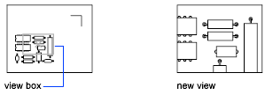

* To change the size of the view box, click, resize it, and click again to accept the new size of the view box.
* To pan with the view box, drag it to the location you want and press Enter.

**Extents**

Zooms to display the maximum extents of all objects.

The extents of each object in the model are calculated and used to determine how the model should fill the window.

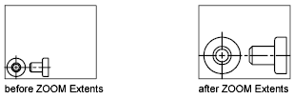

**Previous**

Zooms to display the previous view. You can restore up to 10 previous views.

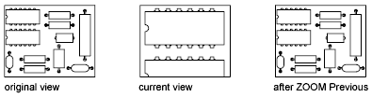

**Scale / Scale factor**

Zooms to change the magnification of a view using a scale factor.

* Enter a value followed by **x** to specify the scale relative to the current view.
* Enter a value followed by **xp** to specify the scale relative to paper space units.

For example, entering **.5x** causes each object to be displayed at half its current size on the screen.

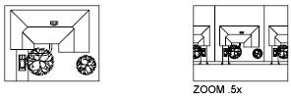

Entering **.5xp** displays model space at half the scale of paper space units. You can create a layout with each viewport displaying objects at a different scale.

Enter a value to specify the scale relative to the grid limits of the drawing. (This option is rarely used.) For example, entering **2** displays objects at twice the size they would appear if you were zoomed to the limits of the drawing.

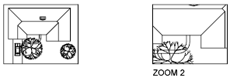

**Window**

Zooms to display an area specified by a rectangular window.

With the cursor, you can define an area of the model to fill the entire window.

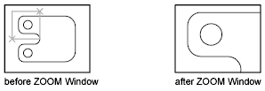

**Object**

Zooms to display one or more selected objects as large as possible and in the center of the view. You can select objects before or after you start the ZOOM command.

**Real Time**

Zooms interactively to change the magnification of the view.

The cursor changes to a magnifying glass with plus (+) and minus (-) signs. See Zoom Shortcut Menu for a description of the options that are available while zooming in real time.



Holding down the pick button at the midpoint of the window and moving vertically to the top of the window zooms in to 100%. Conversely, holding the pick button down at the midpoint of the window and moving vertically to the bottom of the window zooms out by 100%.

When you reach the zoom-in limit, the plus sign in the cursor disappears, indicating that you can no longer zoom in. When you reach the zoom-out limit, the minus sign in the cursor disappears, indicating that you can no longer zoom out.

When you release the pick button, zooming stops. You can release the pick button, move the cursor to another location in the drawing, and then press the pick button again and continue to zoom the display from that location.

To exit zooming, press Enter or Esc.

**Pan command:-**

 FindPosition the cursor at the start location and press the left mouse button down. Drag the cursor to the new location. You can also press the mouse scroll wheel or middle button down and drag the cursor to pan.

As a view is being panned, the cursor changes to indicate when you have reached the virtual extents of the drawing.

The cursor changes to a hand cursor. By holding down the pick button on the pointing device, you lock the cursor to its current location relative to the viewport coordinate system. The drawing display is moved in the same direction as the cursor.



When you reach a logical extent (edge of the drawing space), a bar is displayed on the hand cursor on that edge. Depending on whether the logical extent is at the top, bottom, or side of the drawing, the bar is either horizontal (top or bottom) or vertical (left or right side).

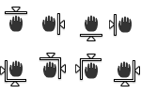

When you release the pick button, panning stops. You can release the pick button, move the cursor to another location in the drawing, and then press the pick button again to pan the display from that location.

To stop panning at any time, press Enter or Esc.



**University of Engineering & Technology, Peshawar**

**Department of Computer System Engineering**

**Engineering Drawing & CAD Lab**

Dated: 17/08/2020

**Lab Report # 05**

**Introduction to Status bar and function of different toggle button in status bar**

*(Snap, Grid, Ortho, Polar, Osnap, Otrack, Dyn)*

**Discuss function of** Each status bar button along with figure

## Toolbars Mod's in AutoCAD 2007:-

As part of the window **AutoCAD** is its status toolbar that contains buttons for ON/OFF function groups during the drawing. When the button is pressed then the active group of concerned functions to their preferences. The status bar contains buttons for the function: **SNAP, GRID, ORTHO, POLAR, OSNAP, OTRACK, DUCS, DYN, LWT, MODEL**.  
  
I usually start with the following function buttons including: Ortho, Osnap, Otrack and Model.  
During the work started drawing a line you can freely activate and deactivate some of the buttons in the status bar, without fear that will stop the action begun drawing a line.  
For example: (AutoCAD tangent to the circle) when you start to draw a line and clicking on the desktop and then you want to connect to the line tangent to the circle already drawn for which sight is not included, simply click on the button OSNAP right mouse button, select the option for the tangent sight click on OK and continue to target the tangent circles in the drawing.  
  
Note that once you start a drawing and you clicked first click to start, no problem you can switch to another window or a function button in the status bar (Help AutoCAD, IE, OE, Photoshop, etc.) and then back into [working **AutoCAD** window](https://autocad-beginners.blogspot.com/2018/01/5-appearance-working-window-in-autocad.html) and continue with his drawing.

[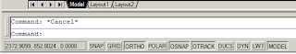](https://3.bp.blogspot.com/-eiJd4GpBkNM/WlppOWk9MsI/AAAAAAAAAkc/RqR4WJxoWw4_kknqohLxdtrQjuNd75-KQCLcBGAs/s1600/status-toolbar.png)

**SNAP** - Function button Snap, on/off option which we determine what will be the support network that is a step that will move the cursor on the drawing. Here note, if you can not click the mouse pointer exactly to a specific location on a drawing, but you always Autocad positioned closest to a town then you SNAP included a big step. Simply turn off SNAP click of a button.  
In the picture below you see that you can set up as desired by the X axis and Y axis (in the picture is 10 units of the spacing between neighboring points), it turns on and off with the (F9).

**GRID** - Also note that on the same card can be On/Off GRID (F7)

[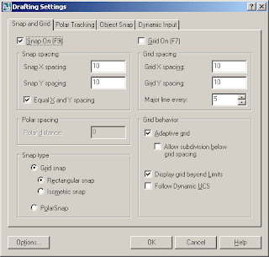](https://2.bp.blogspot.com/-VRdsX4km9kM/Wlpp-OfvzwI/AAAAAAAAAkk/oTVkGzXZqh8futENOSqUmbrnYKFwbiDnQCLcBGAs/s1600/snap.png)

[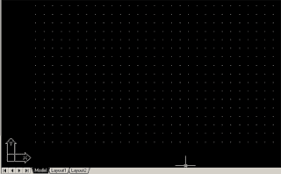](https://3.bp.blogspot.com/-AKLEKLQ_9XY/WlpqObe3wqI/AAAAAAAAAko/xQiE5So04X8tj-GePaYQGhoeDBnwls3WgCLcBGAs/s1600/grid.png)

**ORTHO**- Orthogonal drawing or rectangular drawing, it means that when you turn this feature lines that you drag the mouse will be angled in relation to the UCS and you can draw only the angle that is set and it is 90 degrees.

[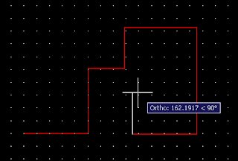](https://2.bp.blogspot.com/-vX1Q0q0TS-4/WlpqbtPS2HI/AAAAAAAAAks/6lfux9pgGTIUhiWqrwh34OYsh3KPuIbCQCLcBGAs/s1600/ortho.png)

**POLAR** - Polar coordinates follow when you draw the line, if this function is activated then the Ortho automatically turned off because when you draw with the POLAR function of the mouse you can draw lines at an angle to the set and you can also set up and draw it with absolute or relative coordinates when drawing lines.

[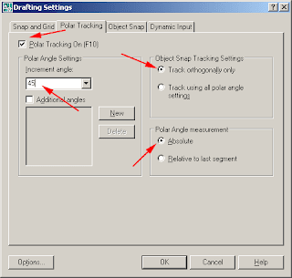](https://2.bp.blogspot.com/-Sd5Au55kWio/WlpqzGGdvhI/AAAAAAAAAk4/xV-8LipwneoqVKo9YiL9Egt8IMxjbo6agCLcBGAs/s1600/polar.png)

[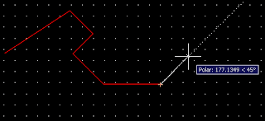](https://2.bp.blogspot.com/-HwnyfYWidcI/Wlpq3xQv-jI/AAAAAAAAAk8/cwBRNv_0PiE4p24EKWXWXSZ5Hsf6aQG_ACLcBGAs/s1600/polar2.png)

**OSNAP** - Aiming (target) at a particular point of a line derived from activated Osnap which contains some basic positions on the line, circle, image, and the like.  
  
Endpoint, midpoint, and other sights for other points of attachment appear only when we turn Osnap mode (and turn on each target). All lines in the figure, circles, etc.. have a connecting point for the target, so to distinguish GRIP (grips) of the target.  
  
BTW: Hindsight is like a magnet, when you approach a point of attachment and appears hindsight, whether you're precisely on a given point or not, just click and Autocad will bind to the target presented.  
SO pay attention! When you close more tombstones (zoom in enough to see a drawing of a tombstone that bind)  
  
**OSNAP mod** : F3 => Endpoint, Midpoint, Center, Node, Quadrant, Intersection, Extension

[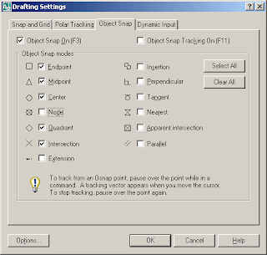](https://3.bp.blogspot.com/-PS4gWmqrH2U/WlprQsVVl-I/AAAAAAAAAlA/McJOb2_zjrIFlfaSlQh8MlkOG-YrBJkKQCLcBGAs/s1600/osnap.png)

**OTRACK** - F11 - Intersetion, Perpendicular, Tangent, Nearest, Apparent intersection, Parallel  
  
If you turn **OTRACK/POLAR** mode then you have an active extra dashed line that helps you draw the line to align with a line (point) to the already drawn parts of the drawings.

[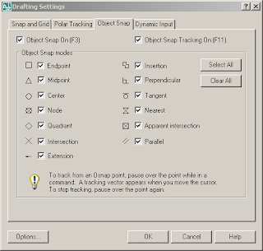](https://1.bp.blogspot.com/-wvAYeTOubiQ/WlprqfkAJVI/AAAAAAAAAlM/Ckfwz3AAU70ssenRo-oDEFcz5JUneNgKQCLcBGAs/s1600/otrack.png)

**DYN** - Turning Dynamic Input for information when drawing

[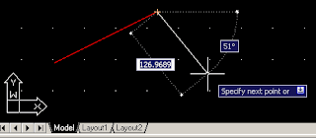](https://2.bp.blogspot.com/-VpWP3yh6QwI/WlptOonW95I/AAAAAAAAAlg/OKIe78IkgyYQjKDrrExd_TzYtWxdw_8sQCLcBGAs/s1600/dyn.png)



**University of Engineering & Technology, Peshawar**

**Department of Computer System Engineering**

**Engineering Drawing & CAD Lab**

Dated: 17/08/2020

**Lab Report # 06**

**Introduction to 3D workspace to 2D, Command Prompt window & Repetition of commands, UCS icon in 2D,** **Blue grip & its size (stretch, lengthen), cross hair (pick box & Size), Selection Window (From Right to Left & Left to Right)**

Discuss functions and Write down a stepwise procedure for using the above options

**Introduction to 3d and 2d workspace:-**

Workspaces are sets of menus, toolbars, palettes, and ribbon control panels that are grouped and organized so that you can work in a custom, task-oriented drawing environment.

When you use a workspace, only the menus, toolbars, and palettes that are relevant to a task are displayed. In addition, a workspace may automatically display the ribbon, a special palette with task-specific control panels.

You can easily switch between workspaces. The following task-based workspaces are already defined in the product:

* 2D Drafting & Annotation
* 3D Basics
* 3D Modeling

For example, when you create 3D models, you can use the 3D Modeling workspace that contains only 3D-related toolbars, menus, and palettes. Interface items that you do not need for 3D modeling are hidden, maximizing the screen area available for your work.

When you make changes to your drawing display (such as moving, hiding, or displaying a toolbar or a tool palette group) and you want to preserve the display settings for future use, you can save the current settings to a workspace.

**Switch Workspaces:-**

You can switch to another workspace whenever you need to work on a different task from the Workspace Switching button on the status bar at the bottom-right of the application window.

Find

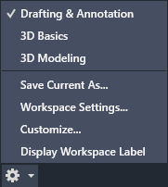

**Command prompt window:-**

## Docking the Command Window

A docked command window is the same width as the application window. It is displayed in a fixed location above or below the drawing area.

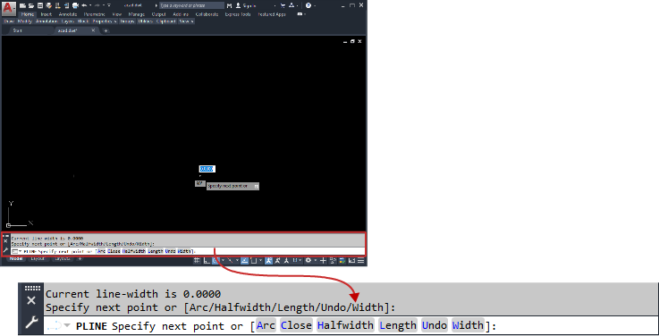

Drag the command window to dock or undock.

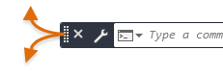

The command window is docked by default for certain operating systems and Windows themes.

**Repetition of the command:-**

Repetition of the command means to use again last command. For this happened the short cut in the key board is (ctrl + space). Previous used command automatically click again by this shotcut.

**UCS icon in 2d:-**

The UCS is a moveable Cartesian coordinate system that establishes the XY work plane, horizontal and vertical directions, axes of rotation, and other useful geometric references. You can change the UCS origin and orientation for convenience as you specify points, enter coordinates, and work with drawing aids, such as Ortho mode and the grid.

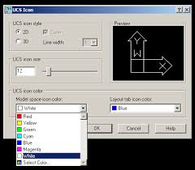

**Blue grip and it size:-**

Entity grips allow AutoCAD drawings to be edited in an entirely new way. Without entering any edit commands, you can stretch, move, copy, rotate, scale, and mirror entities. You can also snap to geometric features such as endpoints, midpoints, centers, quadrants without entering object snaps.

While the default behavior of basic grips is to Move or Stretch, you can right-click on a selected grip to access additional options including Rotate, Scale, and Mirror. You can even copy the object as you edit it as well as specify a basepoint or reference distance. You can do all of this directly from the selected object without ever launching a command!

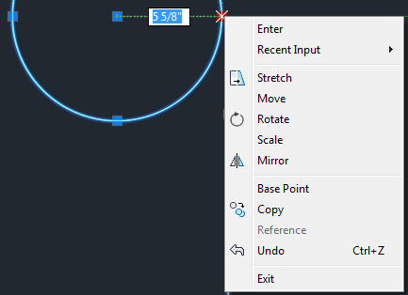

**Cross hair pick box:-**

When AutoCAD prompts you to *select objects,* such as when you are erasing objects, the cursor (crosshairs) turns into a square. This square is called a Pick box. The size of the Pick box can be changed. Some AutoCAD users prefer large boxes, some like small boxes. The size of the box is your personal preference, however, the smaller the Pick box the more accurate you must be when placing the pick box on an object to select it. If the Pick box is too large it could overlap onto other objects that you did not want to select.

**HOW TO CHANGE THE PICK BOX SIZE:-**

1. Select TOOLS / OPTIONS
2. Select the SELECTION tab.

*The following dialog box will appear.*

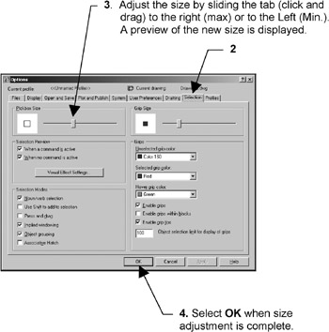

**Selection window:-**

To make a window selection click at any point in the drawing area and drag the cursor towards right side to include the objects in the selection window. All the objects which are completely inside this solid window will be selected, as shown in the image below.

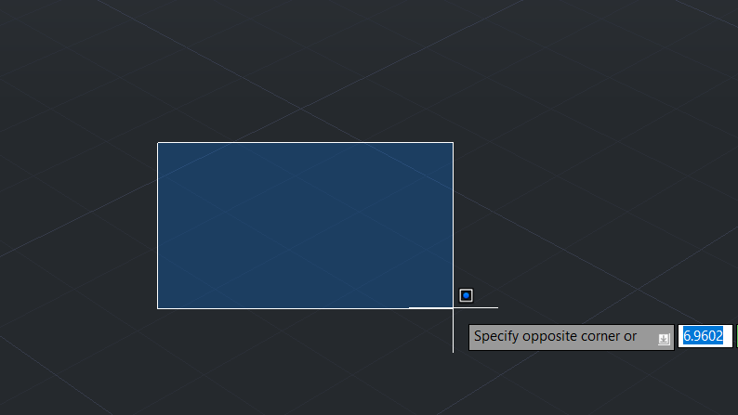



**University of Engineering & Technology, Peshawar**

**Department of Computer System Engineering**

**Engineering Drawing & CAD Lab**

Dated: 07/07/2020

**Lab Report # 07**

**Introduction to AutoCAD Coordinate system**

**(Absolute, Relative & Polar Coordinate System)**

Discuss each Coordinate system in detail with figure and images if required

**Coordinate system:-**

Using coordinates to specify locations can be a challenge in AutoCAD.  It helps to take our time to understand the underlying concepts.

Note the UCS icon.  It is composed of stubs sticking out in the x-direction, the y-direction, and, the z-direction.  The z-direction is hidden if you are working in 2D, but you can think of it as coming out of the page (or monitor, I suppose).  The place where the stubs intersect is called the origin.

If you imagine the x-stub extending out indefinitely, this is the x-axis.  If you imagine the y-stub extending out indefinitely, this is the y-axis.   Any point along the floor can be given as (x, y), where x is a distance along the x-axis, and y is a distance along the y-axis.

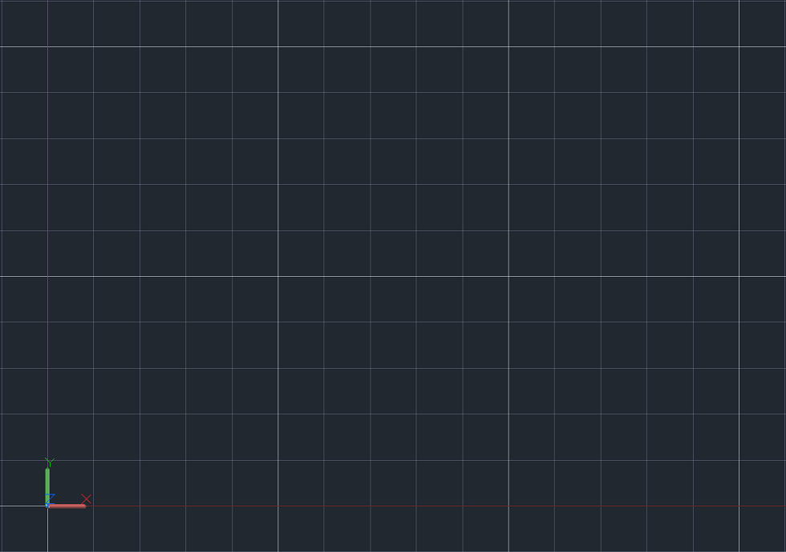

* Conventionally, the x-axis is horizontal, with positive number signifying a move to the right, and a negative number signifying a move to the left.
* Conventionally, the y-axis is vertical, with positive numbers signifying a move up, and negative numbers signifying a move down.

In the status bar at the bottom of AutoCAD, there is a grid that can be turned on or off.  Some people like the grid on in order to facilitate counting along the x and y axis.  The F7 key is a quick way to toggle the grid on and off.  There is also a grid snap tool (F9), which allows snapping to the grid.  Right click on the grid or grid snap tools to change their settings.  Another tool that can be used is ORTHO mode (F8), which constrains cursor movement to the horizontal and vertical directions.



Coordinates, like object snaps, are a way of introducing more precision to our work.

Coordinates act as subcommands in AutoCAD (meaning you need another command active for them to be meaningful).  As an example, you could start a command, such as line, and then practice typing in coordinates and pressing [enter] to place a vertex.   This exercise is fleshed out in the section below.

**ABSOLUTE COORDINATE ENTRY:-**

Absolute coordinate entry is the default.  Absolute coordinate entry always counts from the origin.  When drawing lines, AutoCAD is ready to place the next vertex wherever you tell it to go:

1. Type L on the command line and press enter
2. Type 4,6 on the command line and press enter
3. Type 5,3 on the command line and press enter
4. Press enter to finish the Line command

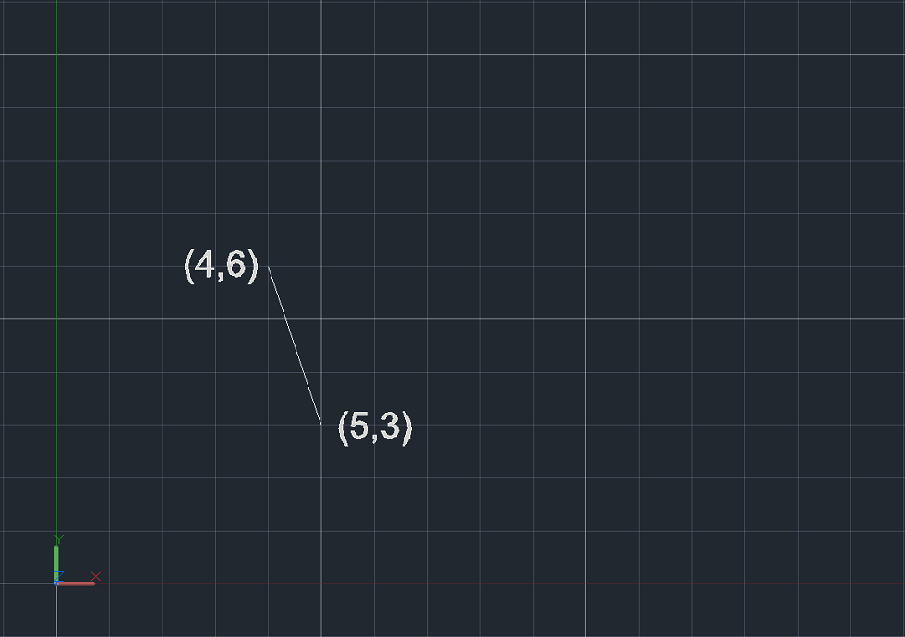

We just told AutoCAD we wanted a line starting at 4,6, and ending at 5,3.  It made a segment between those two points.  The first point is 4 to the right and 6 up from the origin.  The second point is 5 to the right and 3 up from the origin.  The line is the shortest distance between those two points.

**Relative coordinate system:-**

For relative coordinates, AutoCAD does not count from 0,0.  Instead, the reference point is the previous point in the drawing.  Let’s draw another line, and see what it looks like compared to the old one:

1. Type L on the command line and press enter
2. Type 4,6 on the command line and press enter
3. Type @5,3 on the command line and press enter
4. Press enter to finish the line command

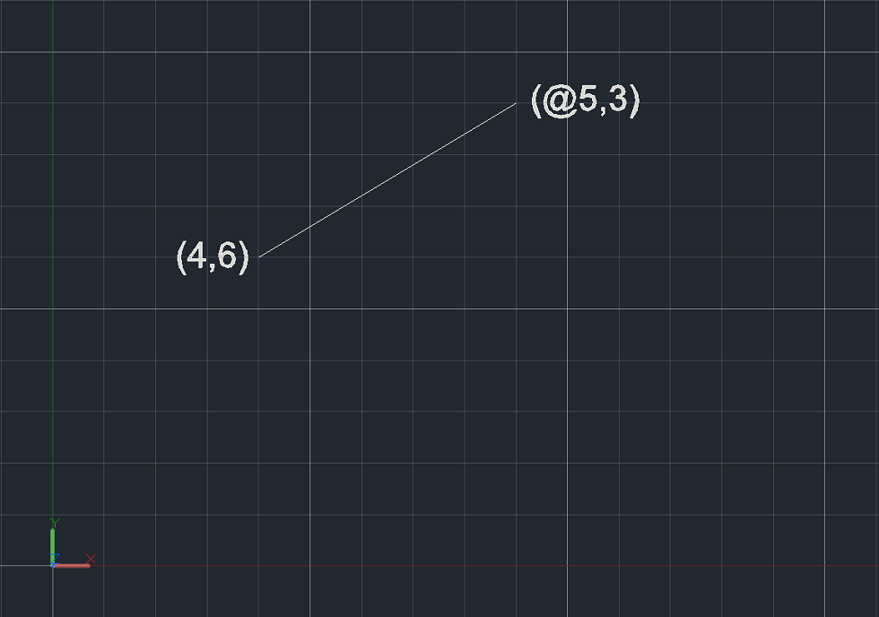

AutoCAD recognizes the @ symbol as instructions to count using relative coordinates.

Notice the difference.  While both lines made thus far started at the same point, this time, for the second vertex, AutoCAD counted 5 over and 3 up from the first vertex, and made the line between those two locales.

**Polar coordinate system:-**

Polar coordinates are named for their “pole”; the reference point to start counting from, which is similar in concept to the origin.  Polar coordinates employ one radial distance and one angle (by convention, the angle is measured counterclockwise from the x-axis).  The angle signifies the direction, and the distance is how far to go in that direction from the pole.

Polar coordinates in AutoCAD are given as R<Degrees, where:

* “R” is the radial distance
* “<” is the less than sign (but in this case represents the angle)
* “Degrees” is the value of the angle in degrees

Like Cartesian coordinates, polar coordinates are employed as a subcommand.

The analogue to ORTHO mode is POLAR tracking (F10).  Polar tracking restricts cursor movement to specified angles.  The user can specify the acceptable angle increments by right-clicking the icon



Relative coordinates also work with polar input.

Let’s delete the lines we drew and work via the command line again:

1. Type L on the command line and press enter
2. Type 4,6 on the command line and press enter
3. Type @5<60 on the command line and press enter
4. Press enter to finish the line command

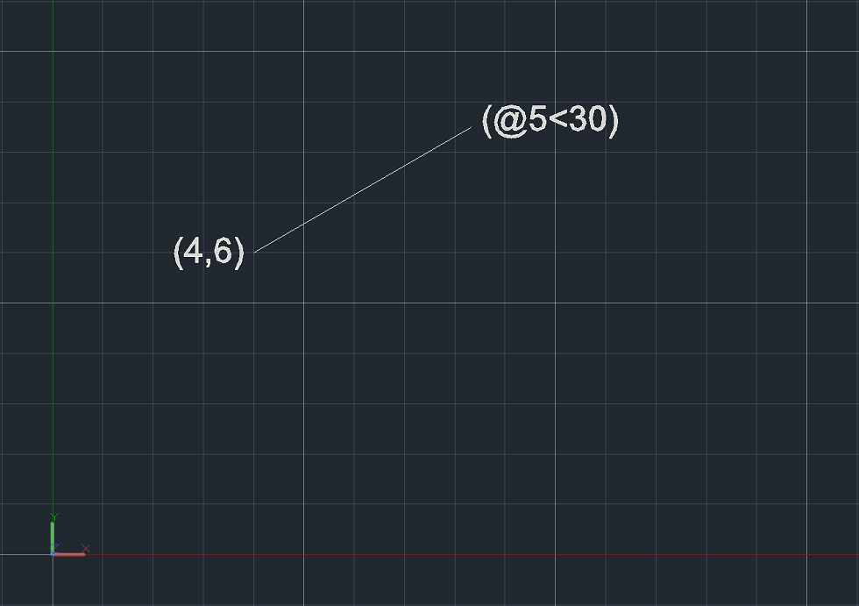

The above line started at 4,6 (which is input in absolute Cartesian coordinates).  Since the next line had the @ symbol, that means the previous point (4,6), became the pole, or reference point for the relative coordinates.

We input the polar coordinates as @5<60, which means the length of the line is 5 and the angle counterclockwise from the x-axis is 60 degrees.



**University of Engineering & Technology, Peshawar**

**Department of Computer System Engineering**

**Engineering Drawing & CAD Lab**

Dated: 17/08/2020

**Lab Report # 08**

**Introduction to Draw Toolbar and different commands**

Discuss each command in draw tool bar in detail with figure and images

**Draw toolbar :-**

Drawing commands are basic commands when creating a drawing, because a simple project can be performed even without editing tools. **we will explore the AutoCAD Drawing Toolbar**, which includes commands for drawing standard primitive objects: x line, ray, line, circle, rectangle etc., as well as drawing tools for creating complex objects: spline, ellipse, polyline etc. The “Drawing” section will also be of interest to users who are already working in the program, **because the entire functionality of the drawing commands** will be parsed.

### **Group of Tools:-**

Let’s start our introduction to tools one by one. We have different groups of tool here such as Draw, Modify, Annotation, etc. We will learn all the groups.

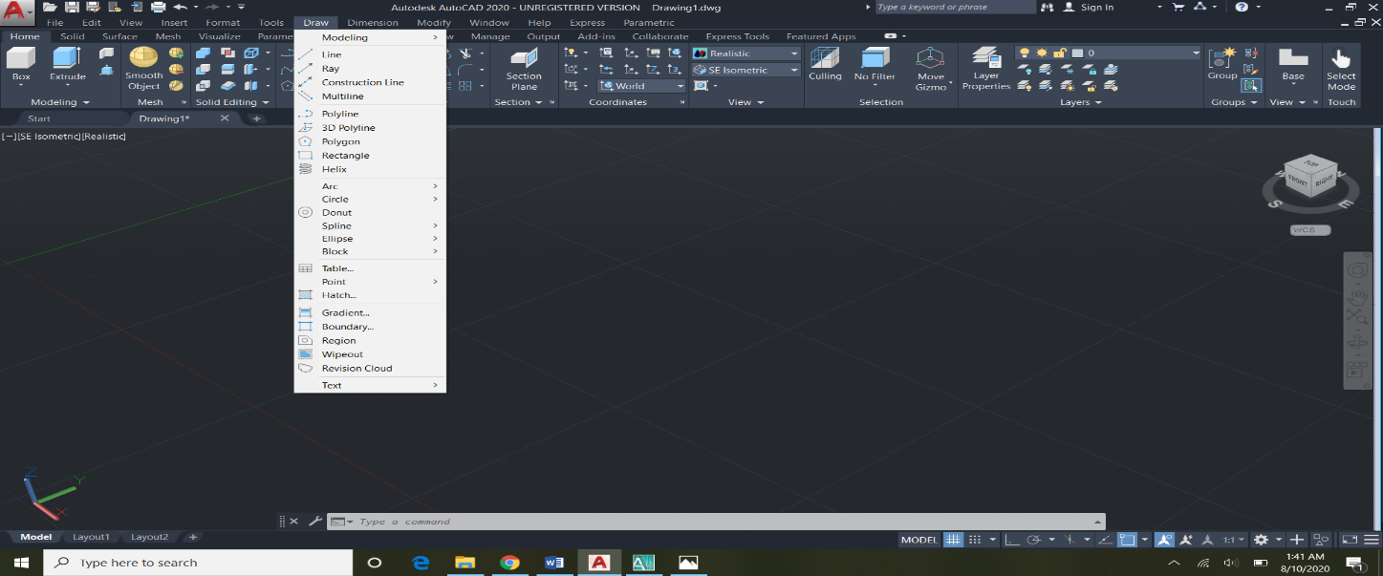

#### Line Tool:-

**Step 1:** Take line command from draw group tool by simply left-clicking on it.

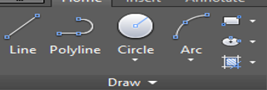

**Step 2:** Next, we will specify the first point from where we want to start our line by simply clicking on the working area and then set a length of 60 mm- then press Enter key.

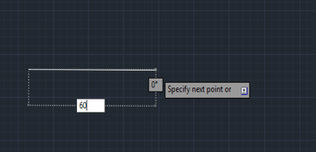

**Step 3:** For creating straight-line turn ‘Orth On’ by pressing F8 on the keyboard or click on the Orth option at the lower right corner.

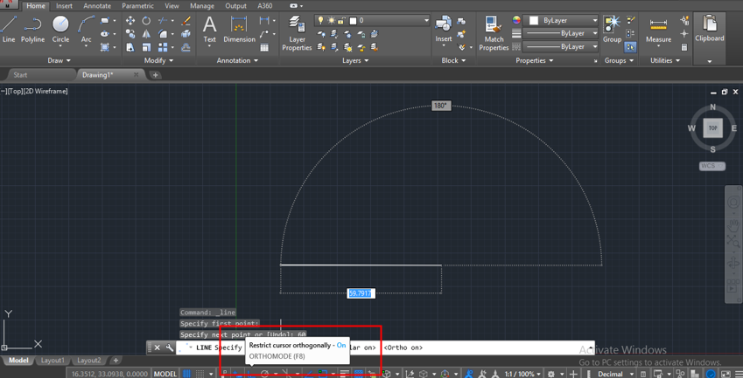

**Step 4:** Here you can also draw a line with any angle and first give length then press the tab key and give angles. I will give length 40 mm and angle 30 degrees and press Enter key.

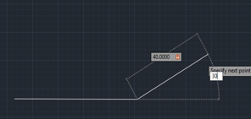

**Step 5:** For exiting from any command press Enter or Esc key on the keyboard.

#### **Polyline Tool:-**

**Step 1:** Take polyline command to draw toolbar group and follow the same steps as we did in the line command.

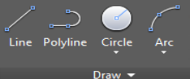

**Step 2:** The major difference in line and polyline is that the object created by line does not work as one object but polyline makes one object as shown in the below image.

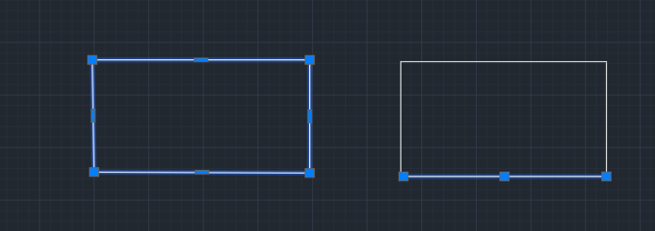

#### **Circle Tool:-**

**Step 1:** Take circle command from the Drag tool group.

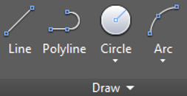

**Step 2:** Now specify the first point.

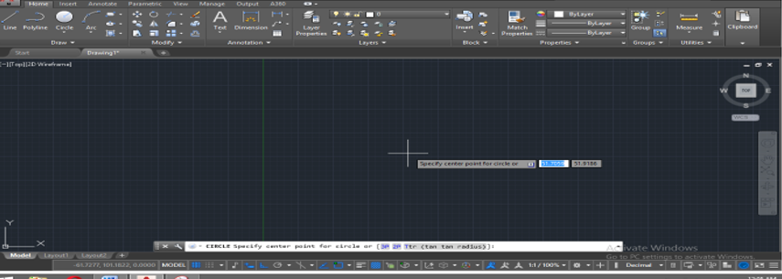

**Step 3:** Give the radius and press Enter key.

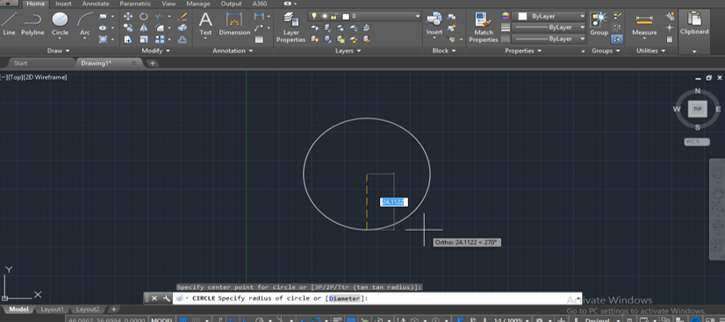

**Step 4:** We have different types of circle drawing options in circle command you can use them according to your requirement.

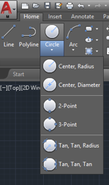

#### **Arc Tool:-**

**Step 1:** Arc command is used for creating an arc in different types of drawings.

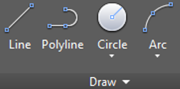

**Step 2:** Take arc command and specify the start point by clicking on any point.

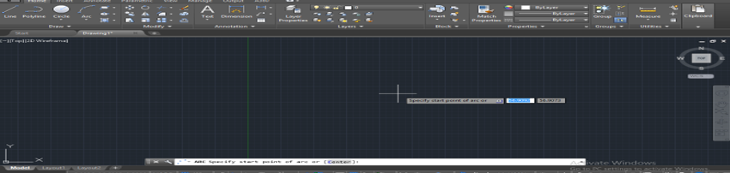

**Step 3:** Give the value of the second point where you want the arc.

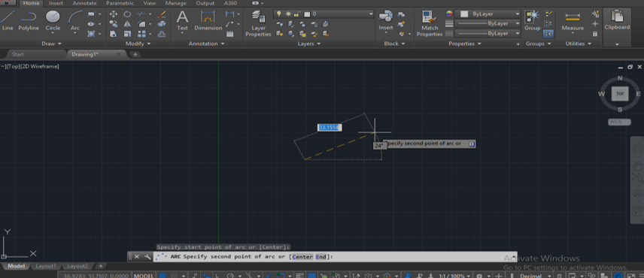

**Step 4:** Specify endpoint or value where you can connect the arc or end the arc.

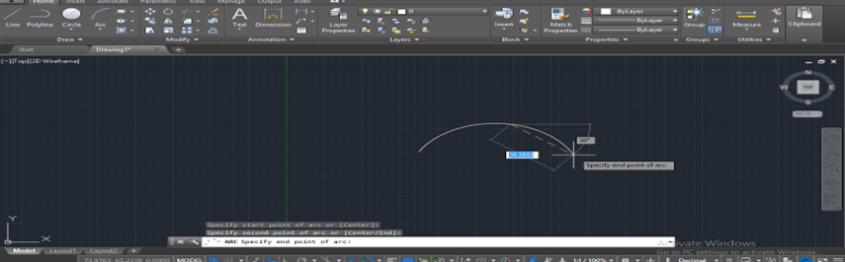

**Step 5:** We have different types of arcs here which we use according to our requirement.

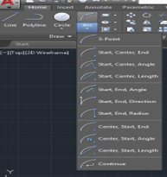

#### Rectangle Tool

**Step 1:** Take a rectangle tool from the draw tool group.

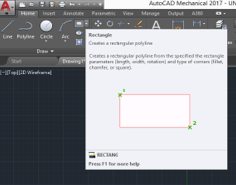

**Step 2:** Give the first corner from where you want to draw a rectangle.

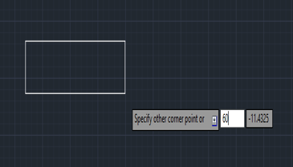

**Step 3:** Then give length and press tab to give breadth according to you and press Enter.

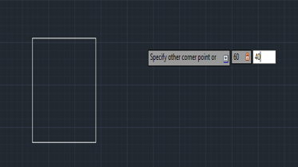

#### **Pentagon Tool:-**

**Step 1:** Take the pentagon command from the draw tool group. For drawing it first give the number of sides press Enter key.

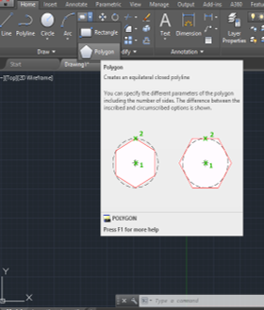

**Step 2:** Give the center point of the pentagon.

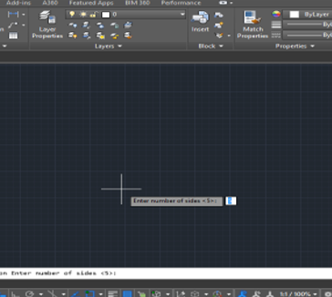

**Step 3:** It will ask now whether it is inscribed in a circle or circumscribed about circle, select anyone according to your requirement.

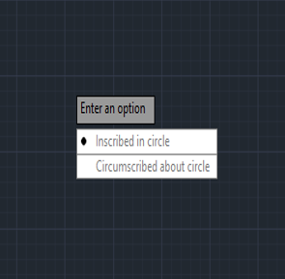

**Step 4:** Give radius and press Enter to complete command.

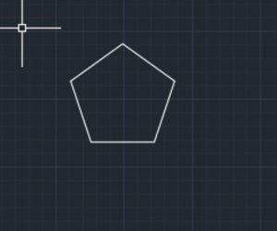

#### **Ellipses Tool:-**

**Step 1:** Take the ellipses tool from the draw tool group.

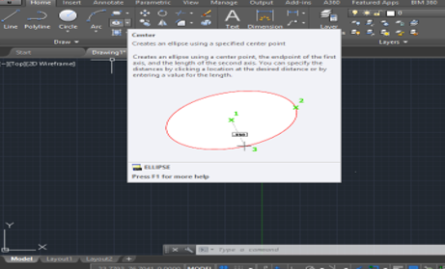

**Step 2:** Specify center point and give endpoint.

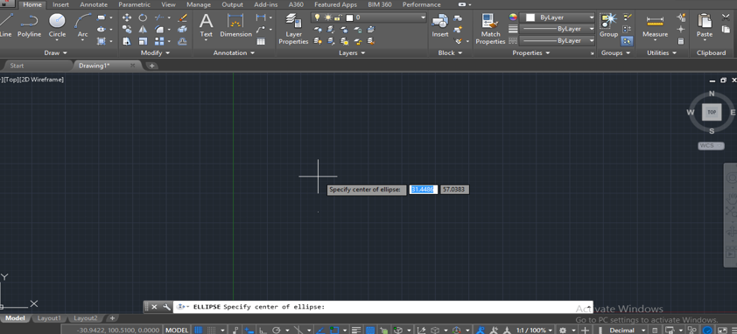

**Step 3:** Set the radius according to your requirement and left click to complete the command.

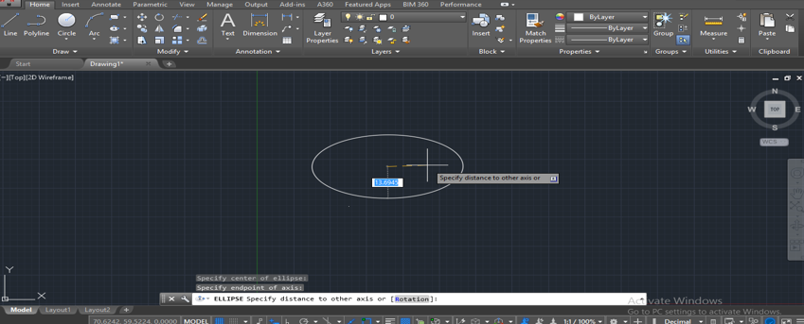



**University of Engineering & Technology, Peshawar**

**Department of Computer System Engineering**

**Engineering Drawing & CAD Lab**

Dated: 17/08/2020

**Lab Report # 09**

**Introduction to Modify Toolbar and different commands**

Discuss each command in Modify tool bar in detail with figure and images

**Modify tool bar:-**

We use this command group for creating any type of modification in the drawn objects. Let’s take a look at some modified commands.

#### **1. Move:-**

**Step 1:** It is used for moving an object from one place to another place.

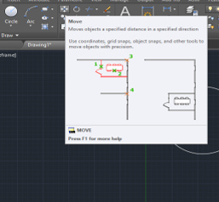

**Step 2:** For moving take move command and select the object then press Enter key and give base point.

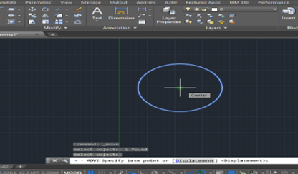

**Step 3:** Give the direction and distance at which point you want to.

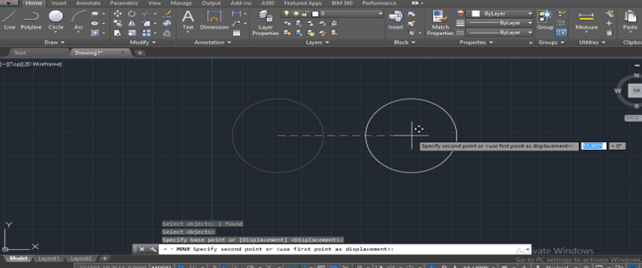

#### **2. Copy:-**

**Step 1:** It is used for copying the object. Take copy command and select object then press Enter key and give base point.

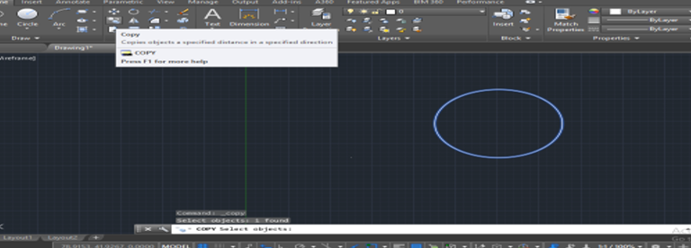

**Step 2:** Give direction and click to leave the copied objects. You can make multiple copies at a time.

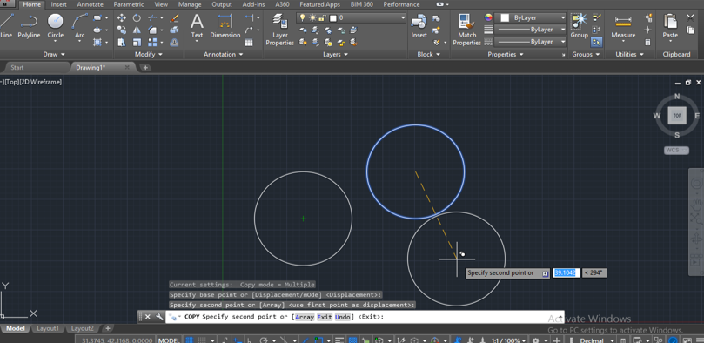

#### **3. Mirror:-**

**Step 1:** It is used for making the mirror of the object.

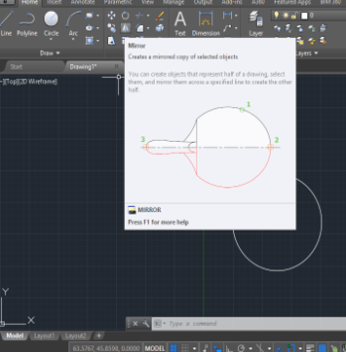

**Step 2:** Take mirror command and select object then press Enter key.

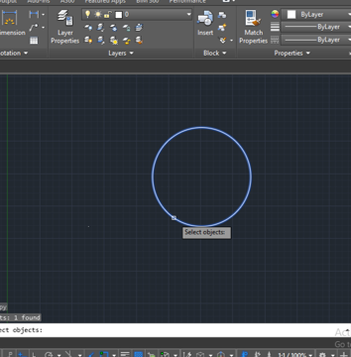

**Step 3:** Give the mirror line then press Enter key say Yes to delete the original object or No if you don’t want to delete it.

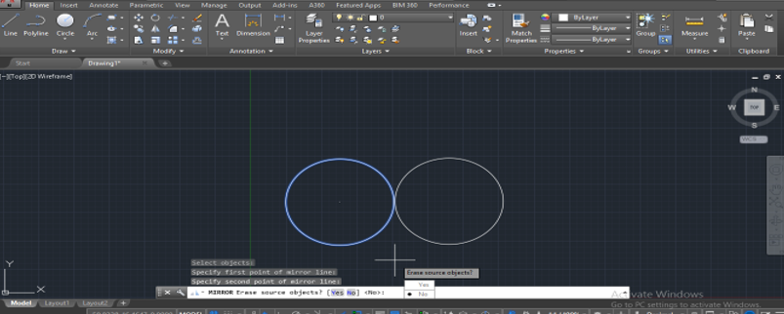

#### **4. Scale:-**

**Step 1:** Take scale and select object then give base point.

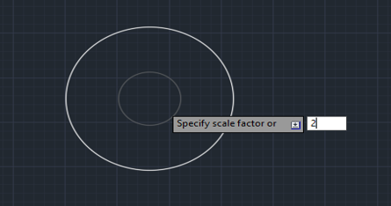

**Step 2:** Give scale factor and press Enter key.

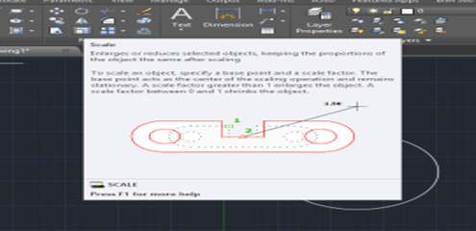

#### **5. Trim**

**Step 1:** Take Trim

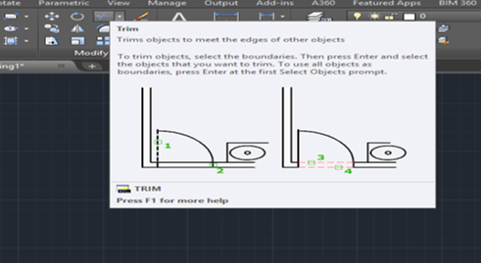

**Step 2:** Select cutting edge then press the Enter key.

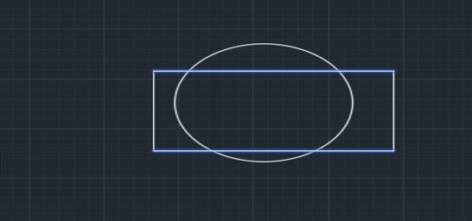

**Step 3:** Select the trimming line and click to trim it.

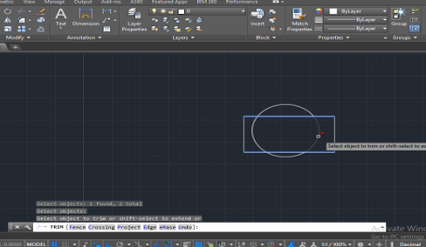

#### 6. **Offset**

**Step 1:** Take the offset and give base points.

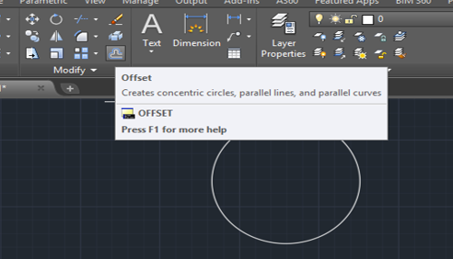

**Step 2:** Press the Enter key to give direction and click to apply this command.

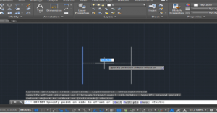

#### **7. Erase :-**

**Step 1:** Select the Erase option.

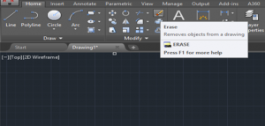

**Step 2:** Select the object and press Enter.

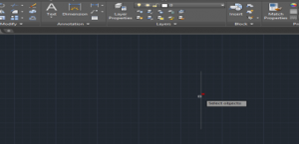

**University of Engineering & Technology, Peshawar**

**Department of Computer System Engineering**

**Engineering Drawing & CAD Lab**

Dated: 17/08/2020

**Lab Report # 10**

**Introduction to Dimension Toolbar and its different commands**

Discuss each command in Dimension tool bar in detail with figure and images

**Dimension tool bar:-**

We use this toolbar for dimensioning of line, arc, circle, angle, etc with proper scales.

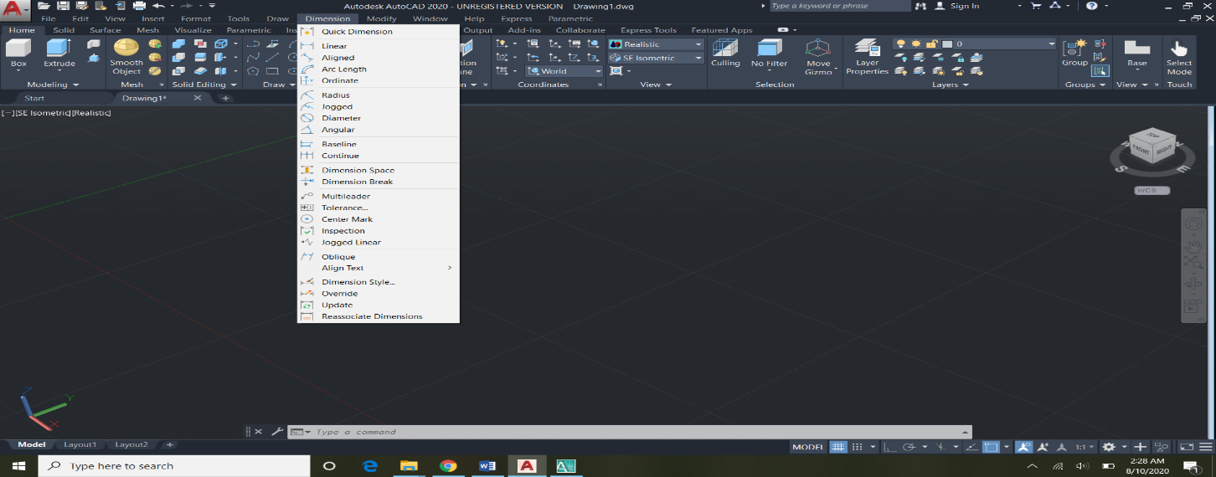

Create linear dimensions with horizontal, vertical, and aligned dimension lines. Create baseline or chained dimensions. Place dimension lines at an angle to the extension lines, or make extension lines oblique.

## Create Horizontal, Vertical, or Aligned Dimensions:-

1. Click Annotate tabDimensions panelDimension.  Find
2. Select a line or specify the first and second extension line origin points.
3. Move your pointing device to the desired position and orientation of the dimension.
4. Before specifying the dimension line location, you can edit or rotate the text.
5. Click to place the dimension line.
6. Repeat steps to continue dimensioning or press Enter to end dimensioning.

Continued, baseline, and ordinate dimensions can be created using the options in this command.

## Create a Linear Dimension with Angled Extension Lines:-

1. Click Annotate tabDimensions panelLinear. 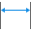 Find
2. Specify the first and second extension line origin.
3. At the prompt, enter r (Rotated).
4. Enter an angle for the dimension line.
5. Click to place the dimension line.

## Create a Continued or Chain Dimension:-

1. Click Annotate tab  Dimensions panel  Continue. 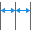 Find
2. If prompted, select the dimension to continue.

Note: This prompt is skipped if the first extension line origin can be assumed from the origin of the second extension line of the last created linear or angular dimension.

1. Use object snaps to specify additional extension line origins.
2. Press Enter twice to end the command.

## Create a Baseline Dimension:-

1. Click Annotate tabDimensions panelBaseline. 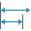 Find
2. If prompted, select the base dimension.

Note: This prompt is skipped if the first extension line origin can be assumed from the last created linear or angular dimension.

1. Use an object snap to select the second extension line origin, or press Enter to select any dimension as the base dimension.

The second dimension line is automatically located at the distance specified by the Baseline Spacing option in the Dimension Style Manager, Lines tab.

1. Use an object snap to specify the next extension line origin.
2. Continue to select extension line origins as needed.
3. Press Enter twice to end the command.

## Modify a Dimension to Specify Oblique Extension Lines:-

1. Click Annotate tab Dimensions panelOblique. 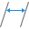 Find
2. Select a linear dimension.
3. Enter a value for the angle of obliqueness, or specify two points.

**University of Engineering & Technology, Peshawar**

**Department of Computer System Engineering**

**Engineering Drawing & CAD Lab**

Dated: 17/08/2020

**Lab Report # 11**

**Practicing 2D figure**

**Figure # 01**

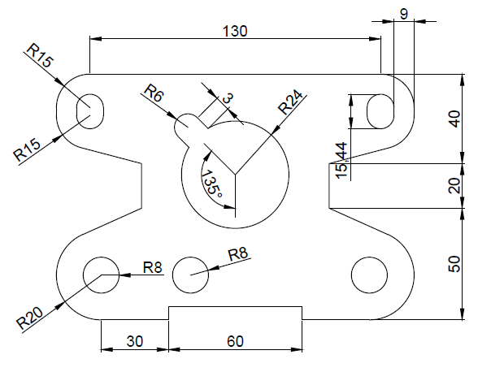

**Sketches:-**

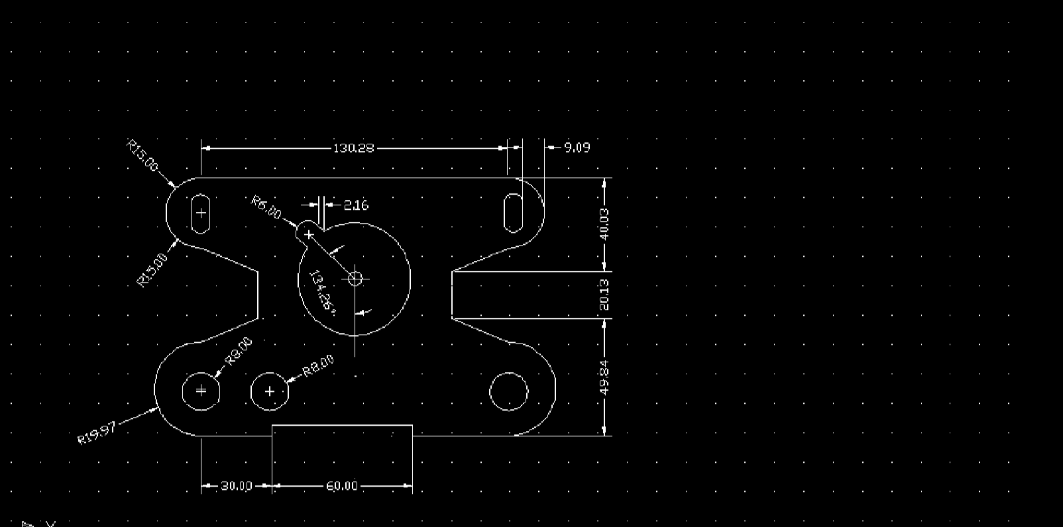

**Steps for Sketches:-**

1. First of all construct a line of 130mm at the top.
2. Draw the reference to sides to make the arcs according to the give scal.
3. Draw the bottom line and draw the another refence line 9mm apart form the first reference line to both sides.
4. Draw the arcs and draw a circle of radius 8mm has center 9mm above the bottom line and 9mm to left of reference line.
5. Offset the circle to other side at the center distance of 100mm and 130mm.
6. Draw the circle 40mm below the top line and at the center of the top line with help of reference.
7. Break the center circle at the angle of 130 degree with the vertical reference line.
8. Draw an arc of radius 6mm at the break point and move it 3mm away with same angle.
9. At last dimension each and every drawing.

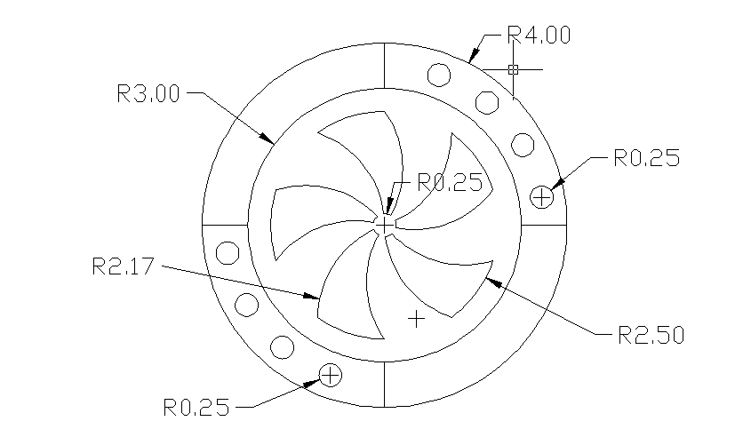

**Sketches:-**

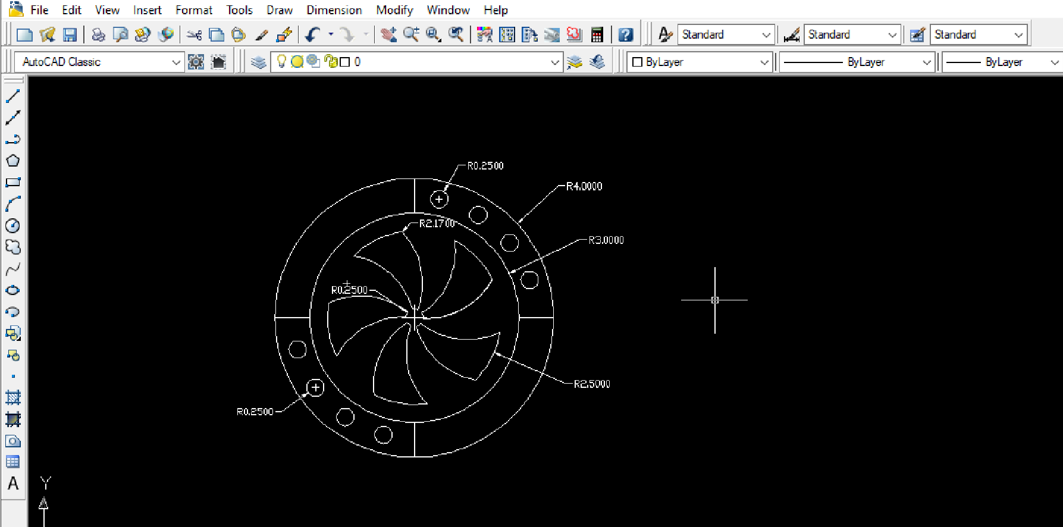

**Steps for sketches:-**

1.First of all drawing sheet limit and unit in mm .

2. Draw the first outer circle of diameter 8mm.

3. Draw more concentric circles of diameter 6mm, 5mm, and 0.5mm.

4.After drawing the circles we create an arc of radius 2.17mm from the first inner circle to second.

5. Use polar array to draw this arc ten times more around the second circle.

6. Use trim command to trim unwanted drawing.

7. Draw the line between the two outer circles.

8. Use again polar array to repeat the line four time between the two circles.

9.at same method draw the four circles of radius 0.25mm.

7. Dimension the drawing using dimension toolbar.

**Figure # 02**

**Draw figure 1 & 2 in AutoCAD and write down the construction step in sequence for each figure**



**University of Engineering & Technology, Peshawar**

**Department of Computer System Engineering**

**Engineering Drawing & CAD Lab (ME-104L)**

Dated: 17/08/2020

(Update the date accordingly)

**Lab Report # 12**

**Engineering Drawing Template creation and title block drafting in AutoCAD**

Discuss the following in this Lab report

1. Learning objectives:
2. Discuss Drawing Sheet and its dimensions (with figures/images)
3. Orientation of Drawing sheet (with figures/images)
4. Title block and its components with figure and images (You can find multiple templates and title blocks in ND Butt, 49th Edition)

*(Attach a sample of template that you created in AutoCAD, which include your name, department, university logo, registration no., etc.)*

1. What is field in AutoCAD
2. Discuss step wise procedure for creating template and title block in detail with figure and images

**Learning objectives:-**

* To know about creation of template in AUTOCAD.
* To understand drafting of title block.
* To know drawing sheet and its dimension.
* To know about the field in AUTOCAD.

**Step wise procedure for creating template:-**

**Step 1:** The first step for creating a custom template is to open the AutoCAD software and select the new drawing option as shown in the image below. It is the same for all the different types of AutoCAD software like mechanical, MEP, electrical, etc.

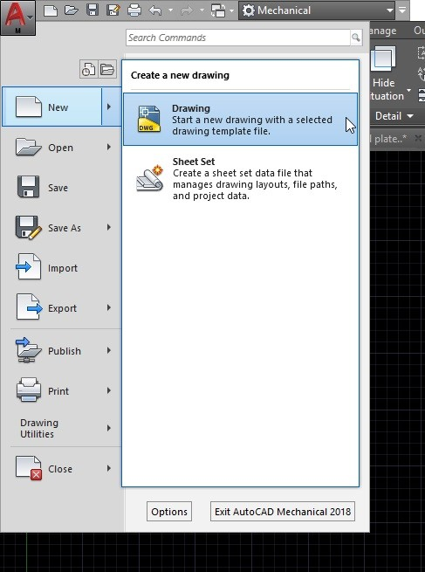

**Step 2:**After selecting the drawing option, another page showing different saved templates will be opened on your screen. From the various files given, select the acad template as shown in the above image and click open. This is the place where our saved templates are located. After saving your custom template you can open it from this location itself.

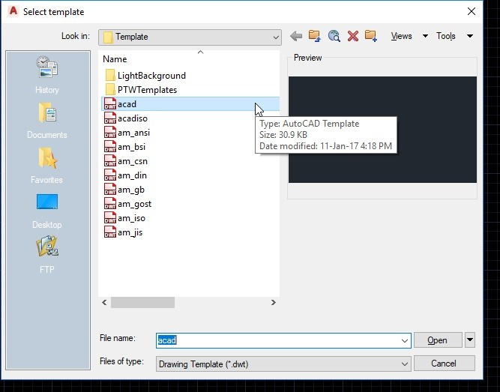

**Step 3:**After this, a new drawing page will be opened in your software. This is the template in which you can set your custom settings. Change whatever settings you want to have in your project. You can set preferences or dimensions in the drawing, you can edit the title block, erase or add drawing elements, update dimension style, etc. After updating all your setting you need to save the template file.

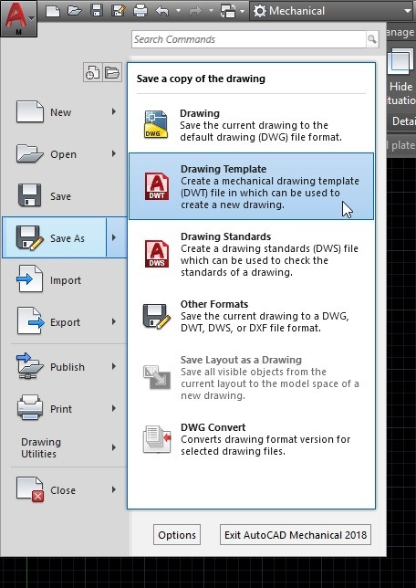

**Step 4:**To save the Templates in AutoCAD you need to click the ‘A’ symbol at the top left corner of the page. Then click save as option and save a copy of the drawing as Drawing Template.  Check the above-given image for your reference.

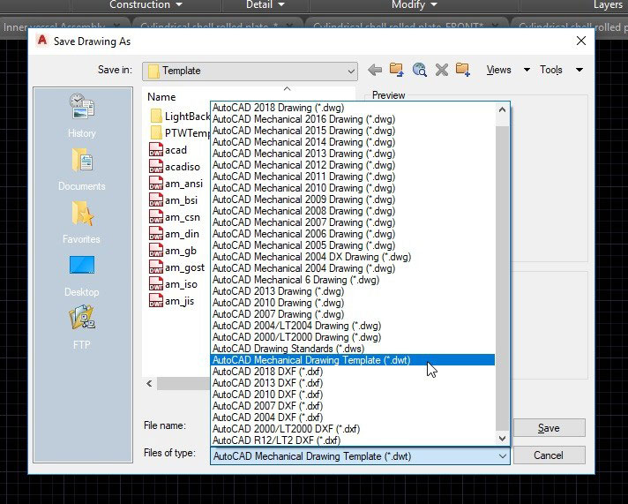

**Step 5:**After selecting the extension, give a name for your file. You can give any name you like. Then save the template as shown in the above image.

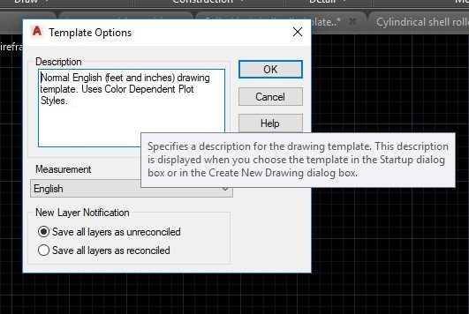

**Step 8:**Once you save a Templates in AutoCAD, it will be available in the template folder and when you open a new drawing you can select your newly made template. As shown in the image above your template will be visible at the end of another template list. Select your template and click open to start drawing using your custom template.

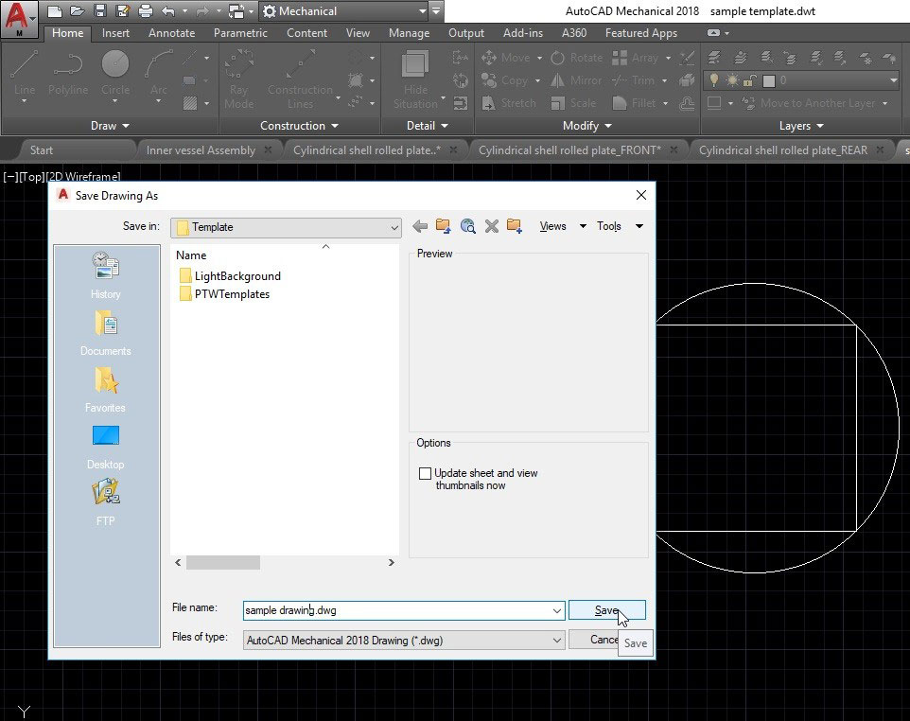

**Title block drafting in AutoCAD:-**

The title block is a border drawing inserted as an AutoCAD block on another drawing. The title block utility can update attributes on the title block.

1. Start a blank new drawing.
2. Draw your drawing border using standard AutoCAD commands and objects.
3. Enter ATTDEF at the command prompt to insert attribute definition objects.

Note: When the border drawing is inserted as a block on another drawing, attribute definition objects become attributes.

1. Enter the Tag name, for example DESC1, DESC2, SHEET, SHEET_TOTAL.
2. Set any other attribute definition properties and values.
3. Select OK.
4. Specify the insertion point.
5. Repeat for each attribute definition for the title block.
6. Save the border drawing as a DWG file.

This drawing is inserted as a block on another drawing. It can be also be inserted when creating a drawing template file, DWT. A drawing template file is used to provide consistency in the drawings that you create by providing standard style, settings, layers, and border.

**My practice title bloke:-**

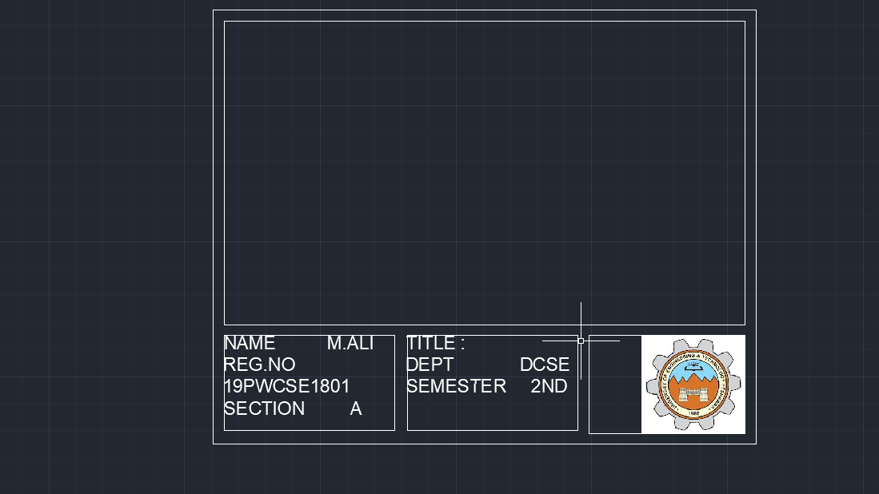

**Drawing Sheet and Dimensions:-**

When you import AutoCAD data into a drawing, dimensions are placed on the drawing sheet as drawing dimensions. The geometry is placed on a sketch associated to a draft view. You can promote the dimensions to the sketch and use them to control the size of the geometry parametrically.

1. Click File  Open.
2. Select an AutoCAD file and click Open.
3. Click Options and select Next.
4. In the Layers and Objects Import Options dialog box, select Next.
5. In the Import Destination dialog box, select Promote Dimensions to Sketch.

You can also promote the dimensions to sketch dimensions after importing an AutoCAD file.

1. Select the dimensions to promote.
2. Right-click and select Promote to Sketch from the menu.

After a dimension is promoted, it behaves the same way as any sketch dimension. You can edit it or change its format and display.

**Field in AUTOCAD:-**

A field is a text string in AutoCAD that contains instructions to display data that you expect to change during the design process or lifecycle of a drawing and/or drawing package. A greyed out area in a drawing indicates that a field has been used and the data is linked to another source.

## Using Drawing Properties

First we will explore how to use the drawing properties button to populate data in the title block. Move to the application browser and select Drawing Properties as shown in Figure 1.

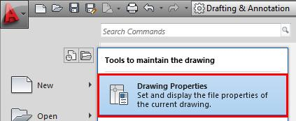

**University of Engineering & Technology, Peshawar**

**Department of Computer System Engineering**

**Engineering Drawing & CAD Lab (ME-104L)**

Dated: 17/08/2020

(Update the date accordingly)

**Lab Report # 13**

**Introduction to Layers in AutoCAD**

Discuss the following in this Lab report

1. Learning objectives:
2. Discuss Layers and layers properties manager (with figures/images)
3. Layers settings (with figures/images)
4. Attach snapshot / image of the layers created and practiced by you

**Learning objectives:-**

* To explain layers in autocad and it characteristic.
* To know how to make different layers for quick access.
* To understand overall setting of the layers.

**Layer:-**

Layers are the primary method for organizing the objects in a drawing by function or purpose. Layers can reduce the visual complexity of a drawing and improve display performance by hiding information that you don’t need to see at the moment.

**layer tools:-**

Use the Layer Properties Manager to manage your layers.  Find

* Create, rename, and remove layers
* Set the current layer on which new objects are automatically created
* Specify the default properties for objects on the layer
* Set whether the objects on a layer are displayed or turned off
* Control whether objects on a layer are plotted
* Set whether a layer is locked against editing
* Control the layer display properties for layout viewports
* Sort, filter, and group layer names

Note: You can override any layer property of an object. For example, if an object’s color property is set to BYLAYER, the object displays the color of that layer. If the object’s color is set to Red, the object displays as red, regardless of the color assigned to that layer.

In addition to the Layer Properties Manager, you can access layer tools on the Layers panel on the Home tab of the ribbon.

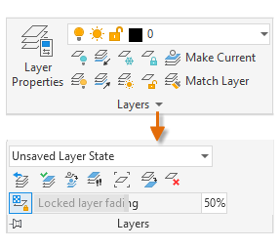

For example, the Off button turns off the layers of any objects that you select.

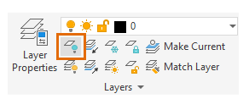

**Current Layer**

All new objects are drawn on the current layer by default. The green check mark on the Layer Properties Manager indicates the current layer.

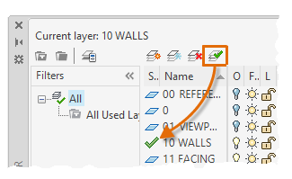

A layer cannot be the current layer if:

* The layer is frozen
* The layer is part of an external reference

For certain types of objects, you can specify a default layer other than the current layer by setting a system variable. These include the following objects:

* Dimension objects: DIMLAYER system variable
* Text and Mtext objects: TEXTLAYER system variable (added in the 2020.1 update)
* Hatch objects: HPLAYER system variable
* Centerline objects: CENTERLAYER system variable
* Center Mark objects: CENTERLAYER system variable
* Converted SHX text from imported PDF files: PDFSHXLAYER system variable

Layer Visibility

You can control the visibility of objects on a layer by toggling the layer on/off or by using freeze/thaw.

 You can turn layers off and on as needed. Objects on layers turned off are invisible in the drawing.

 Freezing and thawing layers is similar to turning them off and on. However, when working with drawings with lots of layers, freezing unneeded layers can speed up display and regeneration. For example, objects on a frozen layer are not considered during a ZOOM EXTENTS.

**Layer setting:-**

The following are the most commonly used layer settings in the Layer Properties Manager. You click the icon to turn the setting on and off.

* Turn off layers. You turn off layers to reduce the visual complexity of your drawing while you work.

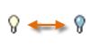

* Freeze layers. You freeze layers that you do not need to access for a while. Freezing layers is similar to turning them off, but improves performance in very large drawings.

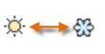

* Lock layers. You lock layers when you want to prevent accidental changes to the objects on those layers. Also, the objects on locked layers appear faded, which helps reduce the visual complexity of your drawing, but still lets you see the objects faintly.

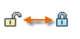

* Set default properties. You set the default properties for each layer, including color, linetype, lineweight, and transparency. New objects that you create will use these properties unless you override them. Overriding layer properties is explained later in this topic.

**Controls in the Layer Properties Manager:-**

To create a new layer, click the button shown and enter the name of the new layer. To make a different layer the current one, click the layer and then click the indicated button.

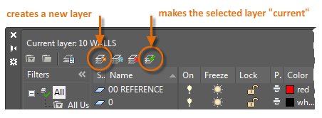

**Quick Access to Layer Settings:-**

The Layer Properties Manager takes up a lot of space, and you don't always need to access all the options. For quick access to the most common layer controls, use the controls on the ribbon. When no objects are selected, the Layers panel on the Home tab displays the name of the current layer as shown here.

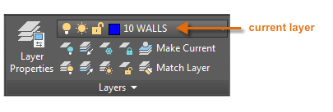

Occasionally, check to make sure that the objects you create will be on the correct layer. It's easy to forget to do this, but it's also easy to set. Click the drop-down arrow to display a list of layers, and then click a layer on the list to make it the current layer. You can also click on any icon in the list to change its setting.

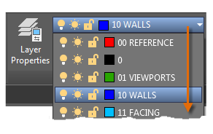

**My practice and layers:-**

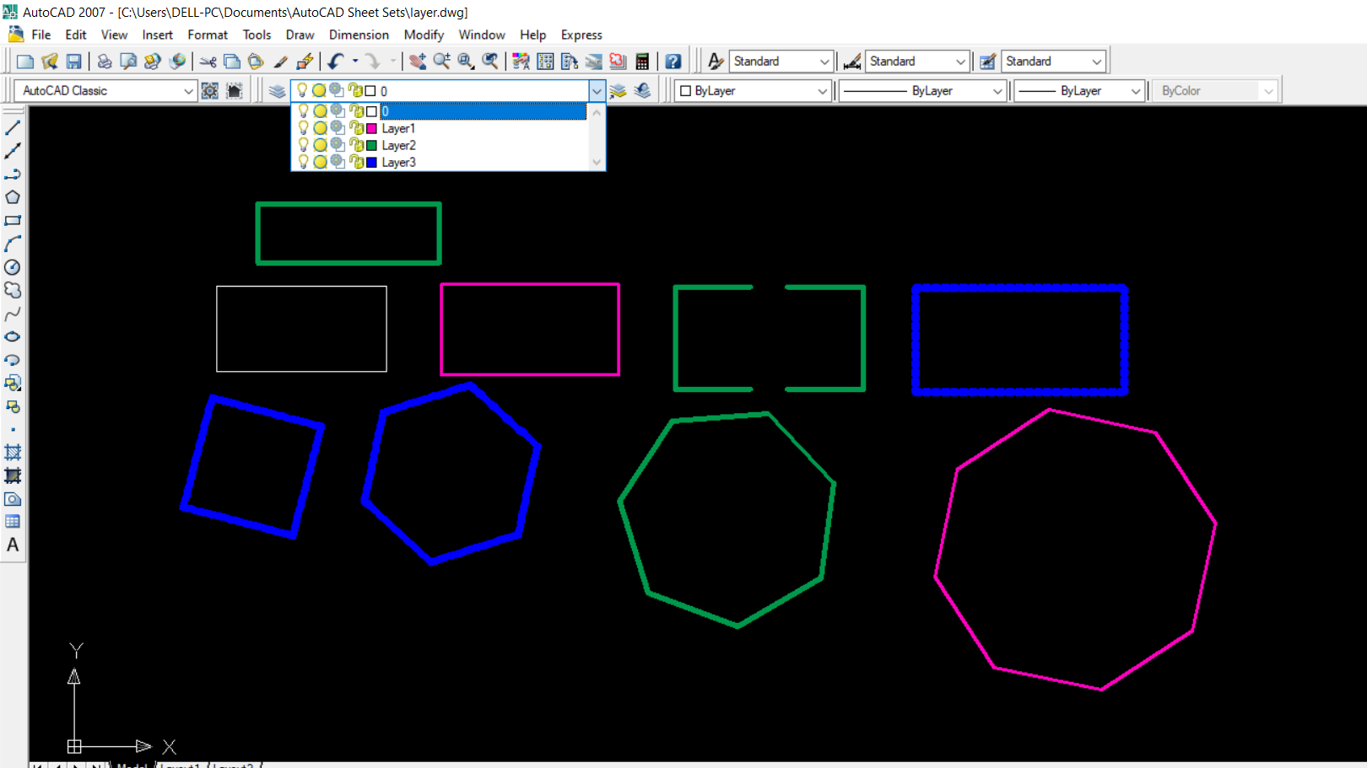



**University of Engineering & Technology, Peshawar**

**Department of Computer System Engineering**

**Engineering Drawing & CAD Lab (ME-104L)**

Dated: 17/08/2020

(Update the date accordingly)

**Lab Report # 14**

**Introduction to 3D modeling, Primitive solids and general solid drafting (AutoCAD V. 2020)**

Discuss the following in this Lab report

1. Learning objectives: (Write by yourself)
2. What is geometric modeling and its types i.e. wireframe etc.
3. Discuss views (Isometric view, orthographic view, oblique view etc.)
4. **Discuss 1st angle of Projection vs 3rd angle of projection**
5. Discuss Primitive solid with figures (Box, Cylinder, Sphere, Cone and pyramid, Polysolids etc.)
6. What is Extrude command, Press-pull commad, sweep, loft, revolve commad.

**Learning objectives:-**

* To know the basic concept of 3D modeling.
* To understand geometric modeling and its types.
* To learn different types of views of an object.
* To know the standard command which convert the object from 2D to 3D solid.

**Introduction to 3D modeling:-**

In 3D computer graphics, 3D modeling is the process of developing a mathematical representation of any surface of an object (either inanimate or living) in three dimensions via specialized software. ... The model can also be physically created using 3D printing devices.

**Isometric view:-**

Isometric drawings are not actual 3D drawings, they are made with 2D geometries but they appear like 3D. Isometric drawing in AutoCAD can be made by tilting viewing angle to 30 degrees for all of its sides in the 2D plane.

Simulate a 3D object from a particular viewpoint by aligning along three major axes

Isometric drawings simulate a 3D object from a particular viewpoint by aligning along three major axes.

By setting the Isometric Snap/Grid, you can easily align objects along one of three isometric planes; however, although the isometric drawing appears to be 3D, it is actually a 2D representation. Therefore, you cannot expect to extract 3D distances and areas, display objects from different viewpoints, or remove hidden lines automatically.

If the snap angle is 0, the axes of the isometric planes are 30 degrees, 90 degrees, and 150 degrees. Once you set the snap style to Isometric, you can work on any of three planes, each with an associated pair of axes:

* **Top** Aligns snap and grid along 30- and 150-degree axes.
* **Right** Aligns snap and grid along 30- and 90-degree axes.
* **Left** Aligns snap and grid along 90- and 150-degree axes.

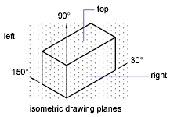

**Orthographic views:-**

You can create custom orthographic views of Plant 3D models and place them in a 2D drawing.

Orthographic drawings are DWG files, and each one can contain multiple orthographic views with data extracted from Plant 3D models. If the source models change, you can update the ortho drawings to reflect the changes.

Orthographic drawings display two-dimensional views of piping, valves, equipment, and structural steel in Plant 3D models. The drawings can have annotations, dimensions, matchlines (plan view only), pipe gaps, and can show or hide lines and objects. Here is an example showing a single view.

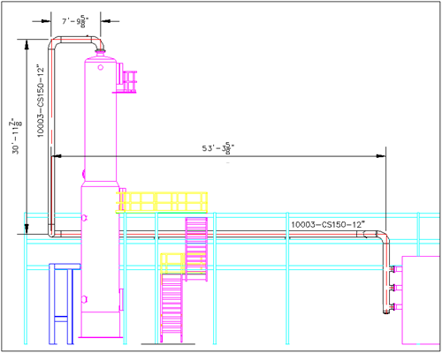

**Oblique views:-**

In oblique views is for making dimension of isometric view.so isometric dimension is:

Isometric dimension:-

Type DIMTEDIT on the command line and press enter then click on the dimension which you want to edit, I am selecting dimension C for this case.



From the command line, select Angle option and type an angle of 30 degrees then press enter. The dimension text will now align with the dimension line. For dimensions, A and B use an angle of 30 and -30 degrees respectively in DIMTEDIT command.

## ****Making Isometric Text:****

To write text on the isometric cube type TEXT on the command line and press Enter. Now click on the face of cube towards dimension C and enter a text height value and rotation angle of 30 degrees in the command line prompts.

Type any text and press enter twice to exit the TEXT command, I am using “Text” as the sample text on the isometric cube.

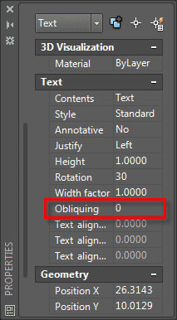

Repeat the process of writing text on the face of cube towards dimension B as well, but in this case change angle of text to -30 degrees keeping all other parameters unchanged.

Now select text on the face of dimension C then right click and select Properties from the contextual menu. From the Text panel of properties palette change value of Oblique to 30.

**1st and 2nd angle projection:-**

To get the **first angle projection**, the object is placed in the **first** quadrant meaning it's placed between the plane of **projection** and the observer. For the **third angle projection**, the object is placed below and behind the viewing planes meaning the plane of **projection** is between the observer and the object.

**1. First Angle Projection:-**  
In the first angle projection, the object is placed in the 1st quadrant. The object is positioned at the front of a vertical plane and top of the horizontal plane. First angle projection is widely used in India and European countries. The object is placed between the observer and projection planes. The plane of projection is taken solid in 1st angle projection.

**Symbol –**

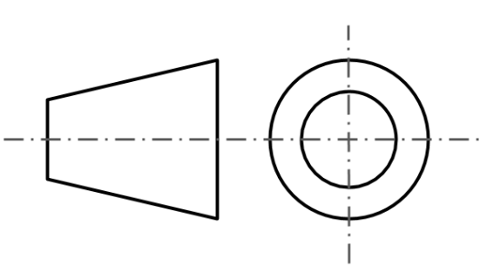

**2. Third Angle Projections :-**

In the third angle projection, the object is placed in the third quadrant. The object is placed behind the vertical planes and bottom of the horizontal plane. Third angle projection is widely used in the United States. The projection planes come between the object and observer. The plane of projection is taken as transparent in 3rd angle projection.

**Symbol –**

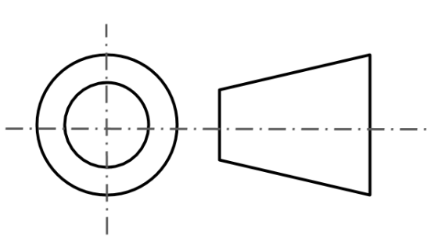

**Primitive solids:-**

Specify 3D Solid Primitives

You can create several basic 3D shapes, known as *solid primitives* with commands such as CYLINDER, PYRAMID, and BOX.

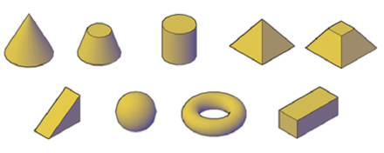

A fast way to create 3D solids in the shape of walls is with the POLYSOLID command. The process is similar to creating polyline including both straight and curved segments, except that you can specify a default height, width, and justification for the resulting 3D solid. You can also convert 2D objects such as a lines, polylines, arcs, and circles to 3D solids with this command.

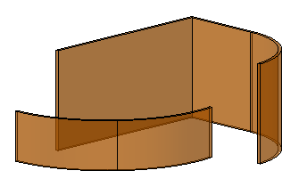

**Extrude Command:-**

Extrude and Presspull Commands are probably the most used AutoCAD 3D tools if not the most used 3D tools. In this article, I will show you eight tips for making efficient use of these commands, let’s start with the Extrude command.

## ****Changing 3D mode:****

There are two modes available with the Extrude command, these are Solid and Surface. You can convert any closed geometry into a solid or a surface by selecting the respective mode from the command line as shown in the image below.



If you apply extrude command on an open 2D geometry a surface will always be created irrespective of the mode selected. Extrude command can be used on Regions too, and you will be able to select Solid or surface mode for Regions also.

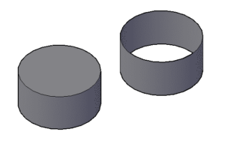

## ****Extrude along direction:-****

By default, extrusion will go perpendicular to profile but by using direction option from the command line we can change the direction of extrusion to an angle other than 90 degrees.

For changing direction select a line or use two points, make sure that the reference line for direction is not on the same or parallel plane of the profile which you are extruding. Take reference of the image below for more.

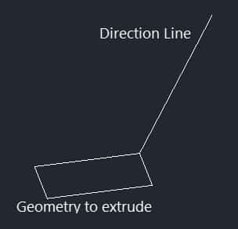

## ****Extrude along the path:****

By using this option you can create extruded geometry along a path as well. The path can be created using an arc, line, polyline or spline and it can even be made away from the geometry. In this case, also the path should not be on the same or parallel plane of the geometry with which extrusion is being made, take reference of the image below.

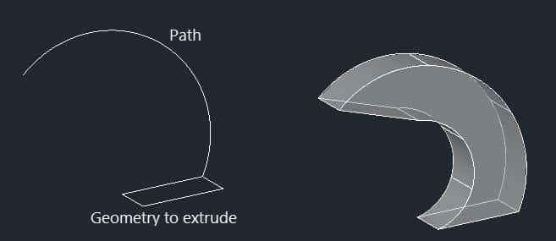

## ****Extruding using taper angle:****

You can taper the extruded object with respect to the axis perpendicular to the plane of the geometry. The positive value of taper angle makes taper inside the profile & negative makes it outside and all faces are tapered equally with respect to the vertical axis.

Specifying large angle may cause faces or loop of the object to meet at a point before reaching extrude height so try to add appropriate value to the taper angle of extrusion. In the image below the taper angle of 10 degrees is applied to the pentagon shape.

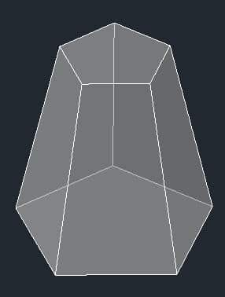

**Presspull command:-**

The Presspull command in AutoCAD 3D is used to create an area formed by the closed boundary.

Or

It is used to pull an enclosed boundary.

It can also be used to create a 3D solid in case of the selected circle or interior of the bounded area.

The objects, such as arc, can be used to create a 3D surface.

The Presspull command is also used to cut a part from the whole object. For example, creating holes, etc.

Consider the below image:

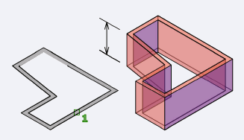

Let's understand by example.

Example 1:

Consider the below 2D surface.



Here, we will extrude the boundary of the hexagon.

The steps are listed below:

1. Select the Presspull icon from the ribbon panel, as shown below:

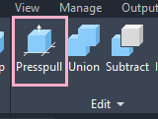

Or

Type PRESSPULL on the command line and < press Enter.

2. Select the object or bounded area.

Here, we will select the bounded area between two edges of hexagon, as shown below:

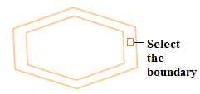

3. Specify the Extrusion height.

Here, we have specified height= 3.

The object will now look like the below image:

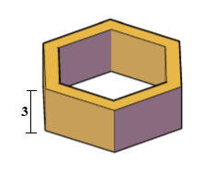

To remove a part of an object,

* Use the Presspull command < select the area to be removed < pull that selected area in outer direction < press Enter.

Let's understand with an example.

Example 2:

Consider the below 2D surface.



Here, we will remove two small rectangles from a big rectangle.

The steps are listed below:

1. Select the Presspull icon from the ribbon panel, as shown below:

Or

Type PRESSPULL on the command line and < press the Enter button.

2. Select the object or bounded area. Here, we will select the rectangle (object).

3. Specify the Extrusion height. Here, we have specified height= -2.

It is because we want to extrude in -Z direction.

The object will now look like the below image:

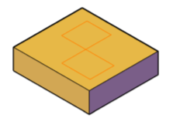

**Revolve command:-**

Creates a 3D solid or surface by sweeping an object around an axis.

 Find

Open profiles create surfaces and closed profiles can create either a solid or a surface. The MOde option controls is a solid of surface is created. When creating a surface, SURFACEMODELINGMODE system variable controls if a procedural or NURBS surface is created.

Revolve path and profile curves can be:

* Open or closed
* Planar or non-planar
* Solid and surface edges
* A single object (to extrude multiple lines, convert them to a single object with the JOIN command)
* A single region (to extrude multiple regions, first convert them to a single object with the UNION command)
* Objects to Revolve
* Specifies the objects to be revolved about an axis.
* Mode
* Controls whether the revolve action creates a solid or a surface. Surfaces are extended as either NURBS surfaces or procedural surfaces, depending on the SURFACEMODELINGMODE system variable.
* Axis Start Point
* Specifies the first point of the axis of revolution. The positive axis direction is from the first to the second point.
* Axis Endpoint
* Sets the endpoint for the axis of revolution.
* Start Angle
* Specifies an offset for the revolution from the plane of the object being revolved.
* Drag your cursor to specify and preview the start angle of the object.
* Angle of Revolution
* Specifies how far the selected object revolves about the axis.
* A positive angle revolves the objects in a counterclockwise direction. A negative angle revolves the objects in a clockwise direction. You can also drag the cursor to specify and preview the angle of revolution.
* 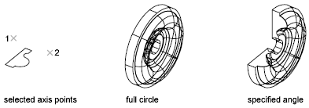

**Loft command:-**

Creates a 3D solid or surface in the space between several cross sections.

 Find

Creates a 3D solid or surface by specifying a series of cross sections. The cross sections define the shape of the resulting solid or surface. You must specify at least two cross sections.

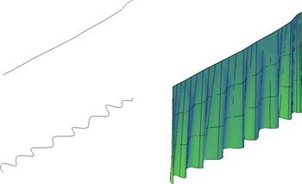

Loft cross sections can be open or closed, planar or non-planar, and can also be edge subobjects. Open cross sections create surfaces and closed cross sections create solids or surfaces, depending on the specified mode.

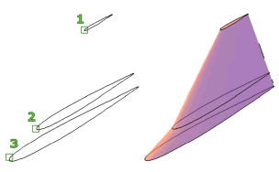

When creating surfaces, use SURFACEMODELINGMODE to control whether the surface is a NURBS surface or a procedural surface. Use SURFACEASSOCIATIVITY to control whether procedural surfaces are associative.

**Sweep command:-**

Creates a 3D solid or 3D surface by sweeping a 2D object or subobject along an open or closed path.

 Find

Open-ended objects create 3D surfaces, while objects that enclose an area can be set to create either 3D solids or 3D surfaces.

**Objects to Sweep**

Specifies an object to use as the sweep profile.

**Sweep Path**

Specifies the sweep path based on the object you select.

**Mode**

Controls whether the sweep action creates a solid or a surface. Surfaces are swept as either NURBS surfaces or procedural surfaces, depending on the SURFACEMODELINGMODE system variable.

**Alignment**

Specifies whether the profile is aligned to be normal to the tangent direction of the sweep path.

If the profile is not perpendicular (normal) to the tangent of the start point of the path, then the profile automatically aligns. Enter No at the alignment prompt to prevent this.

**Base Point**

Specifies a base point for the objects to be swept.

**University of Engineering & Technology, Peshawar**

**Department of Computer System Engineering**

**Engineering Drawing & CAD Lab (ME-104L)**

Dated: 17/08/2020

(Update the date accordingly)

**Lab Report # 15**

**Introduction to 3D commands and 3D solid editing**

Discuss the following in this Lab report

1. Learning objectives: (Write by yourself)
2. Discuss 3D commands (Read last chapter for ND butt, 49th edition)
3. Discuss 3D solid editing (Union, subtract, intersect, shell, slice, etc)
4. Discuss visual styles, view controls and 3D orbit.

**Learning objectives:-**

* To know 3D command and how to activate.
* To understand different command in 3D solid editing.
* To learn how to use 3D orbit and others view controls.

**3D command:-**

**3D ALIGN (Command):-**

Aligns objects with other objects in 2D and 3D.

**3DARRAY (Command)**:-

Maintains legacy behavior for creating nonassociative, 3D rectangular or polar arrays.

**3DCLIP (Command)**

Opens the Adjust Clipping Planes window, where you can specify what portions of a 3D model to display.

**3DCORBIT (Command)**  
Rotates the view in 3D space with continuous motion.

**3DDISTANCE (Command)**Starts the interactive 3D view and makes objects appear closer or farther away.

**3DDWF (Command)**Creates a 3D DWF or 3D DWFx file of your 3D model and displays it in the DWF Viewer.

**3DEDITBAR (Command)**Reshapes splines and NURBS surfaces, including their tangency properties.

**3DFACE (Command)**Creates a three-sided or four-sided surface in 3D space.

**3DFLY (Command)**Changes the 3D view in a drawing interactively to create the appearance of flying through the model.

**3DFORBIT (Command)**Rotates the view in 3D space without constraining roll.

**3DMESH (Command)**  
Creates a free-form polygon mesh.

**3DMOVE (Command)**In a 3D view, displays the 3D Move gizmo to aid in moving 3D objects a specified distance in a specified direction.

**3DORBIT (Command)**Rotates the view in 3D space, but constrained to horizontal and vertical orbit only.

**3DORBITCTR (Command)**Sets a specific center of rotation in 3D Orbit view.

**3DOSNAP (Command)**Sets the object snap modes for 3D objects.

**3D Solid Editing:-**

## Union:-

we can use the Union tool to combine multiple solid entities into a single entity. The image below shows the original 6 solid primitives on the left. On the right, a Union operation joined the boxes together. Two more union operations joined each set of wedges together, resulting in a total of 3 solid entities instead of 6.

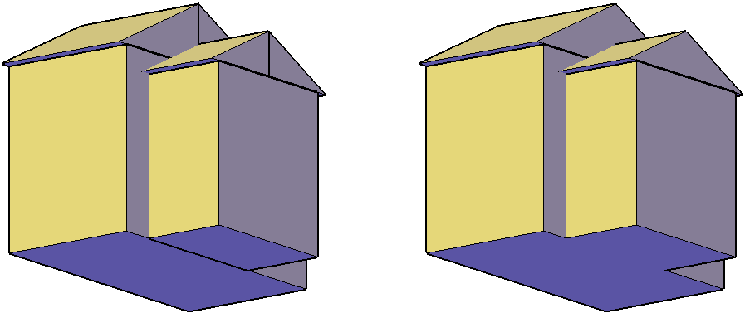

Depending on your design purpose, you can union all the solids together in a single operation. And, you can even union solids that are separated by space.

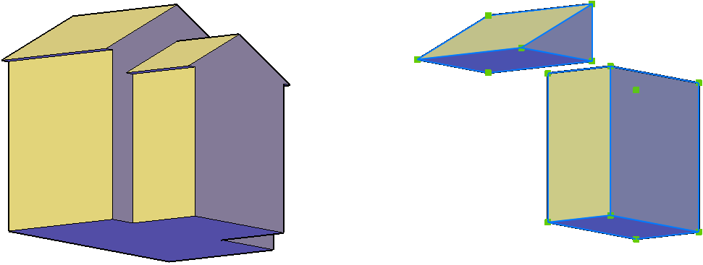

## Subtract:-

The Subtract tool enables you to subtract solid entities from other solids. First we select the entities you want to subtract from, and then you select the entities you want to subtract from them. The second set of entities, the ones you want to subtract from the first set, are removed from the model.

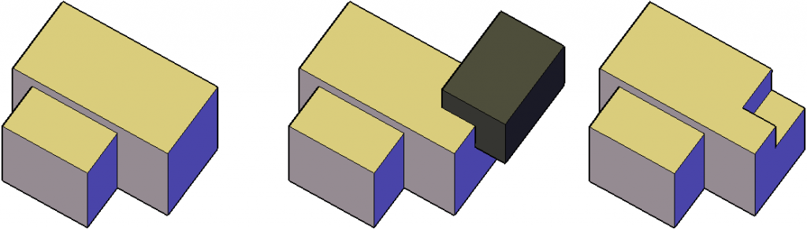

## Intersect

The Intersect tool creates a new solid at the intersection of the selected solids. we can select as many solids as you want but a new solid is only created if it intersects with all the selected solids. In the following image, if we select all three boxes, nothing is created. However, if you select only the two larger boxes, their intersecting solid is created. The original solids are removed from the model.

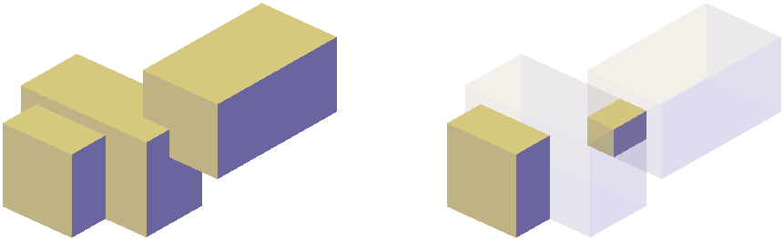

## Interfere:-

The Interfere tool determines the interferences between two selection sets. Each of the two selection sets can include any number of solids. In the following image, the green solids are one selection set and the blue solids are the other. The red solids indicate the interferences between the two selection sets.

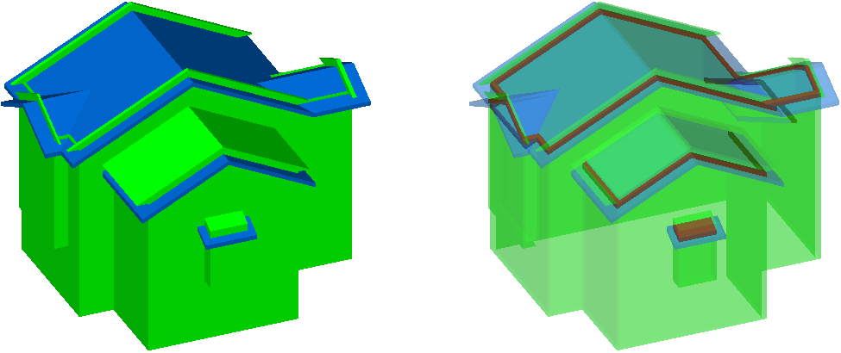

The Interfere tool includes a Settings for us to the behavior and appearance for interferences. By default, it creates the interference solids on their own layer in red. 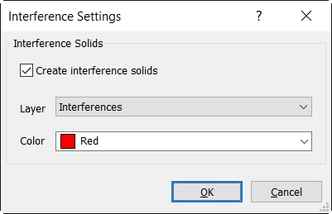

## Slice:-

Use the Slice tool to cut solid entities at a specified plane. we can specify the plane using a variety of options. For example, you can pick a point to slice on the XY, YZ, or ZX planes, select a planar object, or pick three points to define a plane.

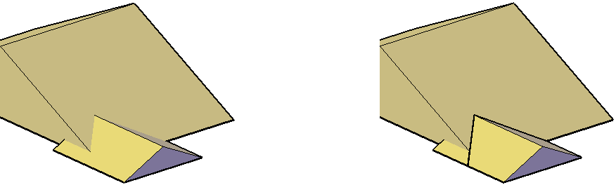

An additional option allows you to slice the solid with a surface. This ability combines the freedom of surfaces with the power of solids.

## Slice to surface

## SOLIDEDIT command:-

The SOLIDEDIT command is an older solid editing tool that offers many options. In fact, most of the tools on the 3D Solid Editing menu launch the SOLIDEDIT command with a particular option selected.

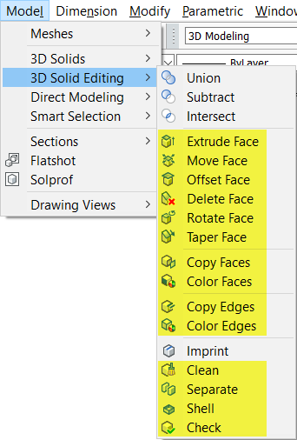

we can access most of the functionality offered by SOLIDEDIT in easier ways using direct modeling. So, I won’t cover all the options. Instead, I’ll focus on the two that I use most, Separate and Shell.

## Separate:-

The Separate tool, within the SOLIDEDIT command, allows you to separate a solid that has non-adjacent geometry into individual entities.

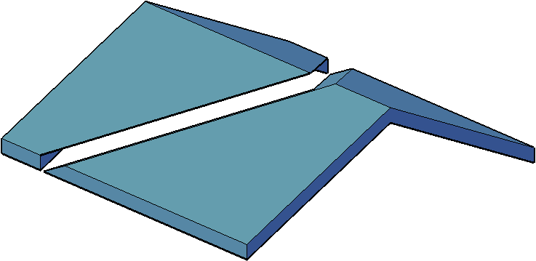

## Shell:-

The Shell tool, within the SOLIDEDIT command, allows you to create a shell from a selected solid.

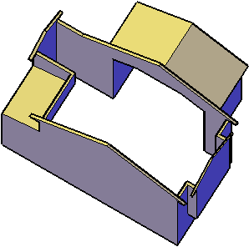

After selecting the solid, you have the option to select faces to remove and you must specify the shell thickness. The Shell tool was used on each of the solids in the following image. The solid on the left does not have any faces removed. From the outside, it appears to be solid all the way through. But, it’s hollow on the inside. The solid in the middle has the top face removed and the solid on the right has the top and front faces removed. The shell thickness is the same in all three solids.

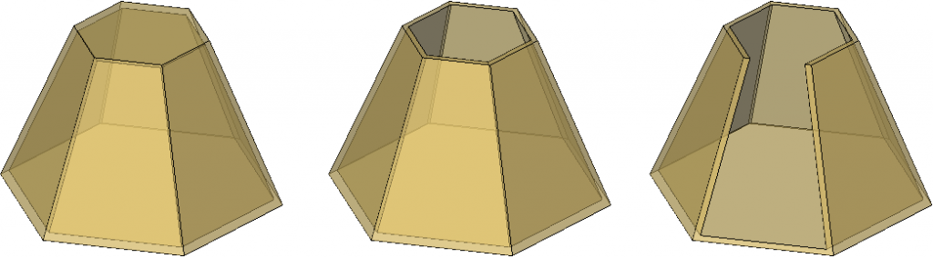

**Visual styles:-**

Visual styles determines the display of edges, lighting, and shading in each viewport.

We can choose a predefined visual style in the upper-left corner of each viewport. In addition, the Visual Styles Manager displays all styles available in the drawing. We can choose a different visual style or change its settings at any time.

**The following predefined visual styles are available by default:-**

* 2D Wireframe. Displays objects using lines and curves. This visual style is optimized for a 2D drawing environment with high fidelity.
* Conceptual. Displays 3D objects using smooth shading and the Gooch face style. The Gooch face style transitions between cool and warm colors, rather than dark and light. The effect is less realistic, but it can make the details of the model easier to see.
* Hidden. Displays 3D objects using wireframe representation and hides lines representing back faces.
* Realistic. Displays 3D objects using smooth shading and materials.
* Shaded. Displays 3D objects using smooth shading.

## Create or Modify Visual Styles:-

We can also define a new visual style by changing its properties in the Visual Styles Manager. It is recommended that we create new visual styles rather than modifying the predefined ones. This ensures that the predefined ones are always accessible.

**3D view control:-**

Select predefined standard orthographic and isometric views by name or description.

A quick way to set a view is to choose one of the predefined 3D views. You can select predefined standard orthographic and isometric views by name or description. These views represent commonly used options: Top, Bottom, Front, Left, Right, and Back. In addition, you can set views from isometric options: SW (southwest) Isometric, SE (southeast) Isometric, NE (northeast) Isometric, and NW (northwest) Isometric.

To understand how the isometric views work, imagine you are looking down at the top of a box. If you move toward the lower-left corner of the box, you are viewing the box from the SW Isometric View. If you move toward the upper-right corner of the box, you are viewing it from NE Isometric View.

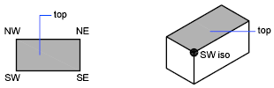

**To Choose a Preset View:-**

1. Click View tab  Views panel  View Manager.  Find

The View tab is not displayed by default, so an alternative method is to enter VIEW at the Command prompt. You can also employ the ViewCube in the top-right corner of the drawing area.

1. Select a preset view (Top, Bottom, Left, and so on).

**3D orbit:-**

3D is use to rotate 3d and 2d objects.

**To Orbit the View of a 3D Object:-**

1. Select one or more objects that you want to view with 3DORBIT or select no objects if we want to view the entire drawing.

Note: OLE objects and raster objects do not appear in the 3D Orbit view.

1. Click View tab  Navigate panel  Orbit drop-down  Orbit. 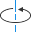 Find
2. Use one of the following methods to orbit around the objects:
   * To rotate along the *XY* plane, click in the drawing and drag the cursor left or right.
   * To rotate along the *Z* axis, click in the drawing and drag the cursor up or down.
   * To allow unconstrained orbiting along the *XY*plane and the *Z* axis, press Shift while we drag the cursor. An arcball is displayed and we can use the 3D Free Orbit interaction.

**University of Engineering & Technology, Peshawar**

**Department of Computer System Engineering**

**Engineering Drawing & CAD Lab (ME-104L)**

Dated: 17/08/2020

(Update the date accordingly)

**Lab Report # 16**

**Dimensioning of 3D Part dimensioning**

Discuss the following in this Lab report

1. Learning objectives: (Write by yourself)
2. Discuss stepwise procedure for 3D part annotation (Watch video lecture)

**Learning objectives**:-

* To know how to dimension the object in 3D workspace.
* To know about 3D annotation.

**Dimensioning of 3D object:-**

Dimensioning in 3D can be a tricky process in CAD. The UCS (the coordinates system used in 3D model space) has to be manipulated so that dimensions are true to their angle an display properly when viewed in 3D.

## 3 Steps to creating a 3D Dimension

Now Piping Spools or any 3D object can be dimensioned at any angle using just a few basic steps.

**Step 1**

Goto a 3D isometric view. Turn on Center and Node snaps, also turn on Polar Tracking as shown in video above.

The first 2 points need to be aligned and on the same axis. We’ll refer to this as co-linear.

If snapping points to be dimensioned are co-linear – pick just 2 points. Enter the points then press enter (or right click your mouse).

**Step 2**

If the points are not co-linear then a total of 4 points are entered. The first 2 define the axis (in step 1 above), then the remaining 2 define the actual points to be dimensioned.

Again, simply enter the points then press enter (or right click your mouse) to exit.

**Step 3**

Edit the 3D dimension if needed. You’ll have the option to Mirror or Flip the dimensions text, relocate the dimension and more.

**Annotation:-**

Use the General Annotation commands to add dimensions, hole notes, and surface texture symbols to the 3D model.

Before we begin, set the units in Document Settings, Standards tab, and then select the desired standard in the Annotations, Active Standard drop-list.

## Add or edit dimensions:-

1. On the ribbon, click Annotate tab  General Annotation panel  Dimension .
2. Select the geometry to dimension.
3. Optionally, do any of the following and then click to place the dimension:
   * Click Select Annotation Plane in the context menu, or use the SHIFT shortcut key, and then select an alternate annotation plane.
   * Click Select Next Candidate Plane in the context menu or use the SPACEBAR shortcut to cycle through alternate planes.
4. Click the drop-list in the minitoolbar and select the dimension style, such as Basic.

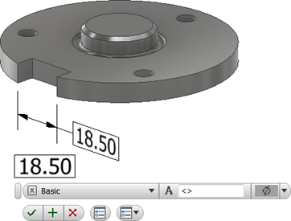

1. Optionally, do any of the following:
   * Place your cursor in the value box and then add prefix or suffix to the value.
   * To access more options, click Edit Dimension in the minitoolbar to display the dialog box and then make any required changes.
2. Click OK to add the dimension.
3. To edit a dimension:
   * Select the dimension in the display or browser, right-click, and select Edit in the context menu.
   * Double-click the dimension in the display or browser.

Change the required dimension values and then click OK.

## To extract existing dimensions:-

To include existing dimensions in the model-based definition:

1. Right-click a feature in the browser and select Show Dimensions.
2. Click any visible dimension and select Promote in the context menu to create a 3D annotation.

If the model dimension includes tolerance information, it is included in the promoted dimension.

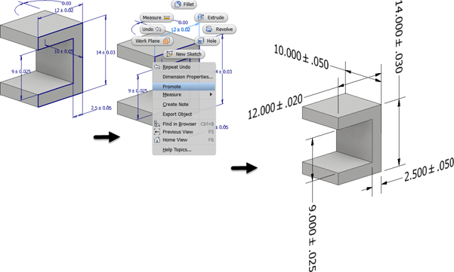

## Add or edit hole/thread notes:-

1. On the ribbon, click Annotate tab  General Annotation panel  Hole/Thread Note .
2. Select the hole feature.
3. Optionally, do any of the following and then click to place the hole note:
   * Click Align to Geometry in the context menu and then select an edge or axis to orient the text.
   * Click Select Annotation Plane in the context menu, or use the SHIFT shortcut key, and then select an alternate annotation plane.
   * Click Select Next Candidate Plane in the context menu or use the SPACEBAR shortcut to cycle through alternate planes.
4. **The following:**
   * Enable the Use Global Precision checkbox or clear the checkbox and then click a drop-list value to change the precision.
   * Enable the Use Part Tolerance checkbox or clear the checkbox and then click a drop-list value to change the tolerance.
   * To access more options, click Edit Hole Note in the minitoolbar to display the dialog box and then make any required changes.

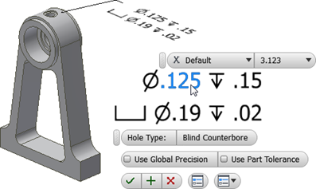

1. Click OK to add the hole/thread note.
2. To edit a hole/thread note:
   * Select the hole/thread note in the display or browser, right-click, and select Edit in the context menu.
   * Double-click the hole/thread note in the display or browser.

Change the required values and then click OK.

## Add or edit surface texture symbols:-

Surface Texture annotations are created with a single-segment leader by default. To create more leader segments, start the command, right-click, and click Single-Segment Leader to unselect the option.

1. On the ribbon, click Annotate tab  General Annotation panel  Surface Texture .
2. Select a model face.
3. Optionally, do any of the following and then click to place the surface texture annotation:
   * Click Align to Geometry in the context menu and then select an edge or axis to orient the text.
   * Click Select Next Candidate Plane in the context menu or use the SPACEBAR shortcut to cycle through alternate planes.
4. Optionally, do any of the following:
   * Click the drop-list and select the desired surface texture symbol.
   * Click a check box next to Force tail, Majority, or All-around to modify the symbol.
   * To access more options and Presets, click Edit Surface Texture Symbol in the minitoolbar to display the dialog box and then make any required changes.

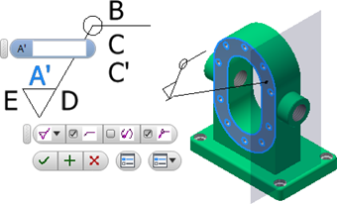

Edit Surface Texture Symbol is located here 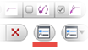 in the minitoolbar. For more on presets see [To Work with Presets](https://knowledge.autodesk.com/support/inventor/learn-explore/caas/CloudHelp/cloudhelp/2019/ENU/Inventor-Help/files/GUID-0FDF0162-5374-4FC8-B6E3-59FDBC9AAA40-htm.html).

1. Click a letter to enable a value box, add the required finish values, and then click OK to create the symbol.
2. To edit a surface texture symbol:
   * Select the surface texture annotation in the display or browser, right-click, and select Edit in the context menu.
   * Double-click the surface texture annotation in the display or browser.

Change the required values and then click OK.

**Instruction for Lab Report**

* It is important to Mention figures/images (if required)
* The heading should be bold (font style: Arial – font size: 10)
* Don’t underline the headings
* Use Time New Roman style for description, unbold and font size should be 10

***Helping Material: Class Lecture, Video Lecture, Use google search and book and slides for writing this Lab Report***



**University of Engineering & Technology, Peshawar**

**Department of Computer System Engineering**

**Engineering Drawing & CAD Lab (ME-104L)**

Dated: 17/08/2020

(Update the date accordingly)

**Lab Report # 17**

**Practicing 3D figure**

**Figure # 01**

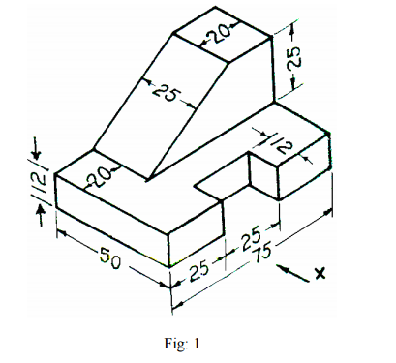

**Figure # 02**

**Sketch:-**

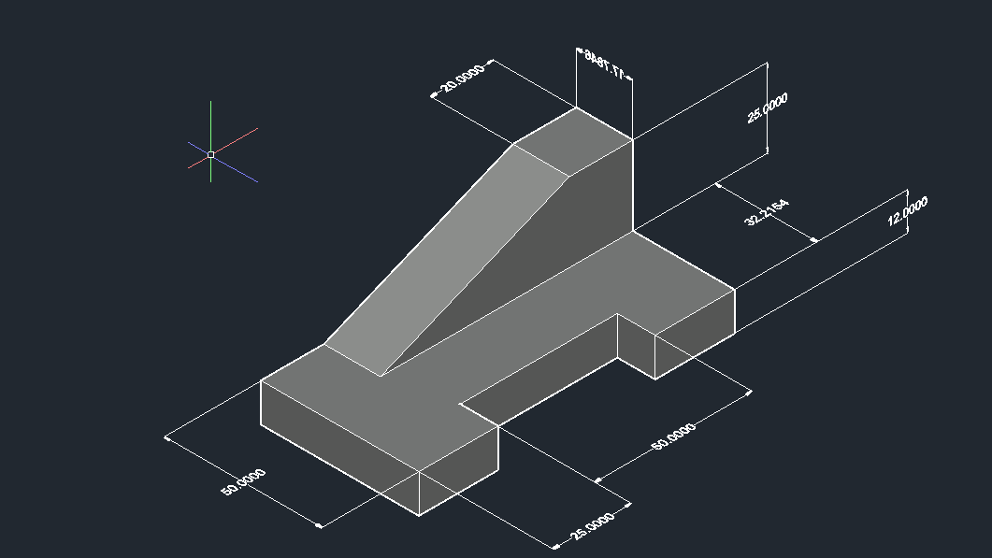

**Steps followed for Sketch:-**

1. First of all draw a line 50mm long in top views after click on Ortho.
2. Draw the 25mm vertical line with the end of 50mm then draw the line 12mm to left and again draw 50mm vertical line then draw 12mm to the right then draw 25mm vertical then draw 50mm to the left and then join to the other end of first 50mm line.
3. Draw the triangle of height 25mm and base 55mm.And click on isometric view.
4. Extrude the first figure above to 12mm.
5. Extrude the triangle to 20mm.
6. Use move command to fit triangle on the figure.
7. And then dimension 3D figure by selection face.

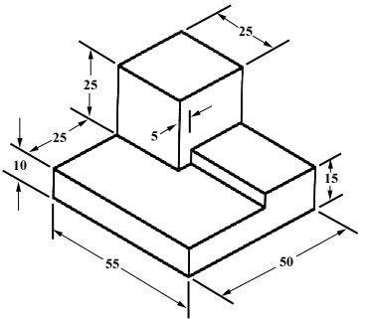

**Figure # 03**

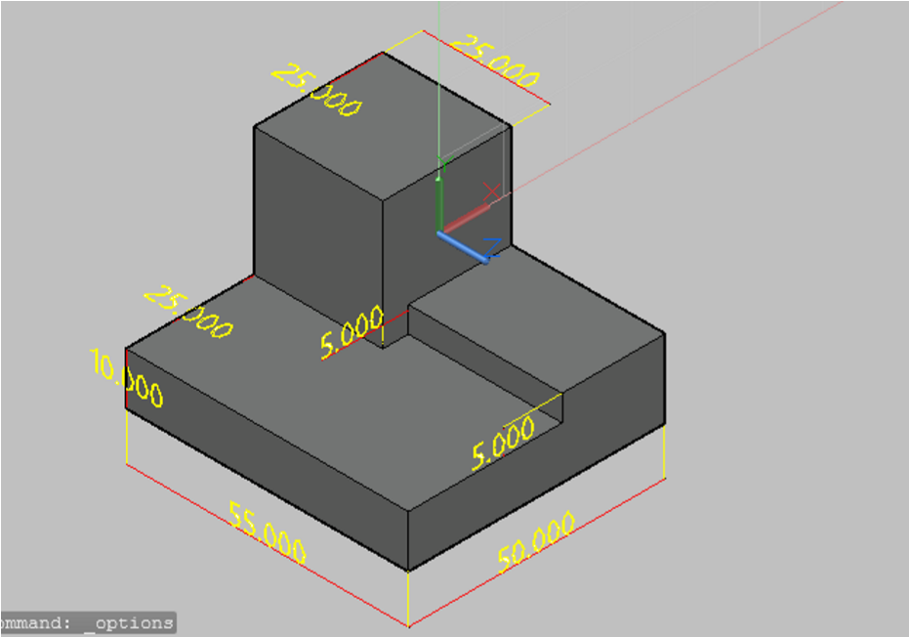**Sketch:-**

**Steps followed for Sketch:-**

1. First of all construct the base 55mm cross 50mm then the other two top objects.
2. First step is to make the splines base, we have to follow the reference image to make the base.
3. After we have made the splines, we have to then extrude the object.
4. After that the remaining two portions, we have to draw splines for them as well.
5. After making splines, we have to then extrude them. One has 25 and the other has 5 extrude amount.
6. After the extrude, we have to then arrange the base points of the top objects, we can do that by moving them in a specific axis using the gismo available when we select any object.
7. After the completion we have to then dimension the figure properly using the annotation tab.

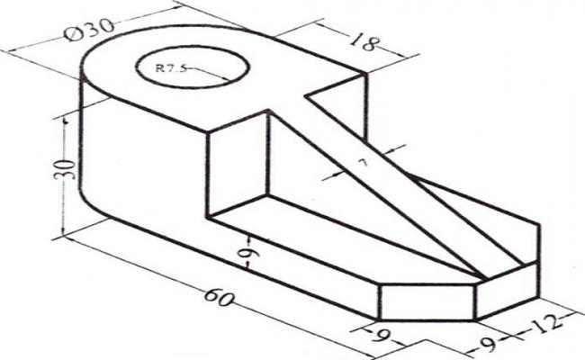

**Sketch:-**

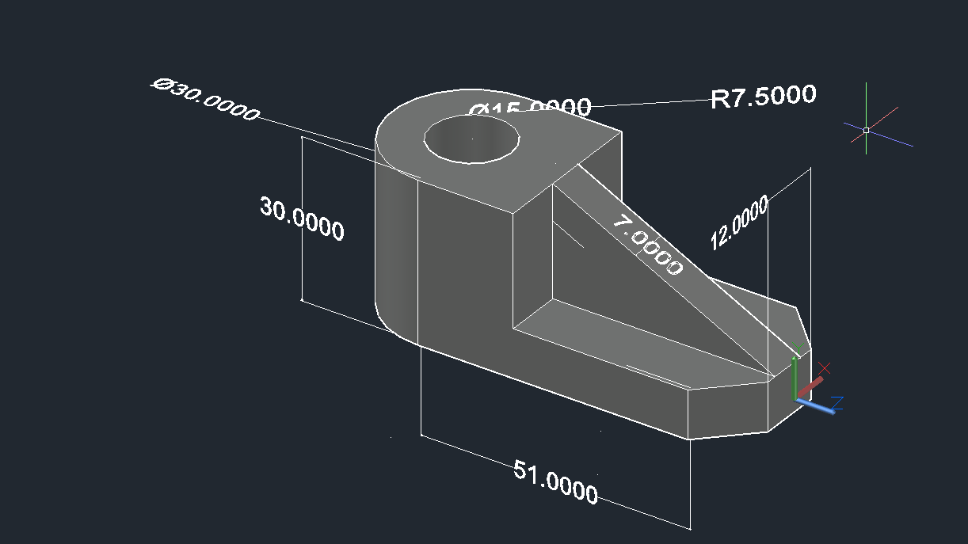

**Steps for sketch:-**

1. First draw 60mm long line.
2. Offset the line 30mm above.
3. Draw the triangle 21mm cross 42mm.
4. Draw a circle of diameter 30mm at one end and curve the other end by intersecting the vertical and horizontal line at 9mm,9mm.
5. Draw another circle concentric to other of radius 7.5mm.
6. And click on isometric view.
7. Extrude it to 12mm and extrude triangle to 7mm.
8. Dimension the figure as the above.

**Draw figure 1, 2 and 3 in AutoCAD and write down the construction step in sequence for each figure**